Lucille (Jones) Lowery
October 29, 1920 – February 2, 1983

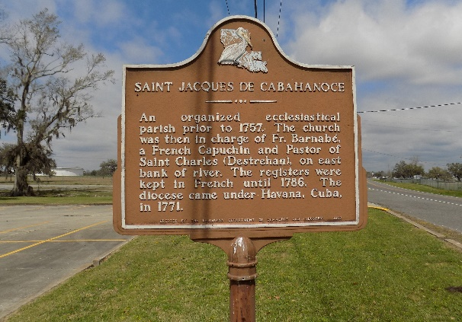

Mrs. Lucille J. Lowery, on Thursday, February 2, 1983, at 10 o’clock a.m., beloved wife of Mr. Lionel Lowery, Sr., daughter of the late Joshua Jones and Gertrude Davis Wells, mother of Michael, Valery, Sr. and Leonel Lowery, Jr., all of Baton Rouge, La., Sidney, Arnold, Ray, Stanley, Sandra, Lurlyn and Yolanda Lowery, all of Donaldsonville, La., and Leo Lowery of New Orleans, La. And the late Carolyn Lowery, sister of Mrs. Goldie Amedee, Johnny Gabriel, Miller and Whelma Jackson, Willie and Fannie Louise Wells, mother-in-law of Barbara, Francis, Betty Jean, Gloria, Audrey B. and Audrey L. lowery, niece of Mrs. Bera Adams, of Chicago, Ill.; also survived by 14 grandchildren, 4 sisters-in-law, numerous nieces and nephews, other relatives and friends; a native of St. James, La. and a resident of Donaldsonville, La.; age 62 years.
Relatives and friends of the family, also parishioners of St. Catherine of Siena Catholic Church, Donaldsonville, La. and St. James Catholic Church and all neighboring churches, officers and members of the Pride of Brookstown Benevolent Association of St. James, La., employees of lowery & Associates Realty Company of Baton Rouge, La., Donaldsonville Polic Dept. are invited to attend the funeral. Services from Brazier-Watson Funeral Home, Donaldsonville, on Monday, February 7, 1983, 11 o’clock a.m. followed by Mass of Christian Burial at St. James Catholic Church, St. James, La., Rev. William hogan officiating. Interment St. James Cemetery.
Wake services will be held at St. Catherine of Siena Catholic Church on Sunday, February 6, 1983. Recitation of the Rosary at 8 p.m. Visitation at St. Catherine of Siena Catholic from 5 to 10 o’clock p.m. Sunday and at the funeral home from 9 a.m. until funeral time Monday. Brazier-Watson Funeral Home in charge of arrangements.

Times-Picayune, New Orleans, Louisiana
February 6, 1983

