Clementine (Weber) Lowery
October 25, 1949 – January 11, 2006

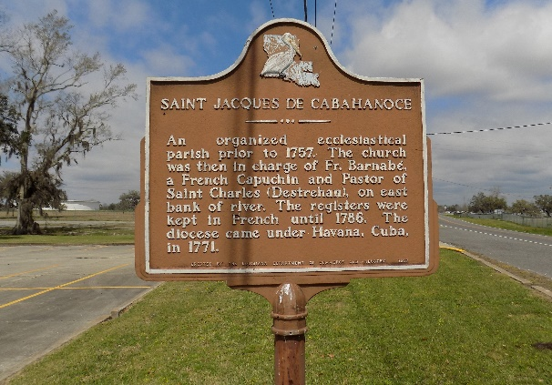

Clementine 'Nooti' Weber Lucas of Vacherie, LA On Wednesday, January 11, 2006, At St. James Hospital, Lutcher, LA.
Daughter Of the Late Marion and Stanley Weber, Sr. Beloved Wife of John (Pappy) Lucas, Sr. Devoted Mother of John Jr., Jynell, Delacy, Andreanlice Lucas and the Late Ashley Lucas. Stepmother Of Karen Batiste, Andrew Brooks, Kevin, Kenneth and Keith Simoneaux. Guardian Of Patrick Major and Jacelyn James. Sister Of Barbara (Joseph) Labranch, Stanley (Gloria) Weber, Jr., Niece of Viola Weber Taylor, Alma Weber, Majorie Lumar and Thelma Lumar. Survived By Sisters and Brothers-In-Law, Nieces, Nephews, Cousins and Friends. A Native of Edgard, LA And a Resident of Vacherie, LA. Age 56.
Relatives And Friends of the Family, Also Priest and Parishioners of St. James Catholic Church, St. John The Baptist Catholic Church and Neighboring Churches, 2nd Ward High School Class Of '69 Are Invited to Attend a Mass of Christian Burial on Wednesday, January 18, 2006, at 11:00 AM from the St. James Catholic Church, St. James, LA. Father Louis T. Oubre, Celebrant. Interment in Church Cemetery. Visitation at the Church after 9:00 AM.

Times-Picayune, New Orleans, Louisiana
January 17, 2006
**

U.S., Social Security Death Index, 1935-2014

Name Clementine M. Lucas
Social Security Number xxx
Birth Date 25 Oct 1949
Issue year 1970
Issue State Louisiana
Last Residence 70086, Saint James, Saint James, Louisiana
Death Date 11 Jan 2006

