Joel Eric Matherne
December 14, 1963 – September 1, 2023

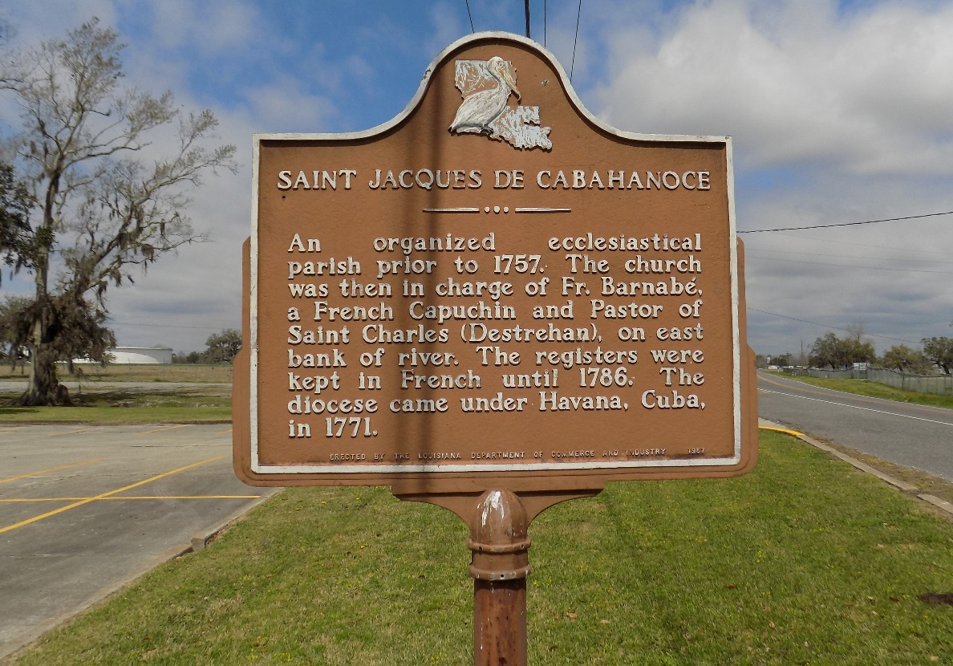

Joel "Happy Jack" Eric Matherne, 59, died Friday, September 1, 2023. Born December 14, 1963 he was a native and resident of St. James, Louisiana.

A visitation will be held on Saturday, September 9, 2023 from 9:00 AM until service time at Saint James Catholic Church in St. James. A Memorial Mass will begin at 10:00 AM at the church with burial following in the church cemetery.

He is survived by his wife of 14 years, Constance Miles Matherne; father, Fred Matherne; daughter, Angelica Lee; step daughter, Laquanta Babin; step son, Glynn Williams (Sagan); siblings, Jeff Matherne (Dawn), Kerry Matherne (Wendy); step grandchildren, Kayden Davis, Rylie Babin, Demi Johnson, Kori Williams, Khai Allen and Kani Williams.

He is preceded in death by his mother, Florence Matherne; one grandchild; mother in law, Australia Miles.

Ordoyne Funeral Home, Thibodaux, Louisiana

