Deloris (Charles) Mayho
September 24, 1938 – September 12, 2012

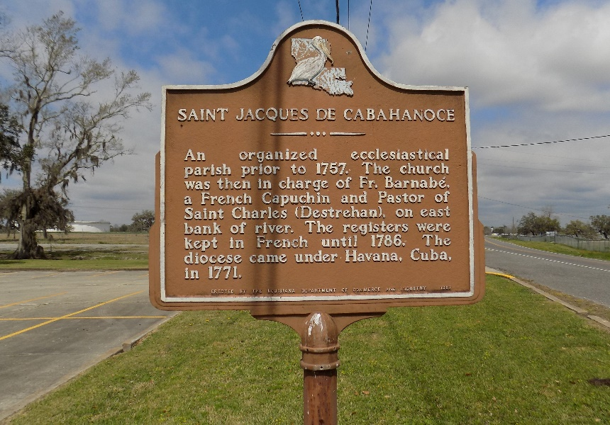

Deloris Mayho - A native of Moonshine, LA, and resident of St. James, LA, she died Wednesday, Sept. 12, 2012, at Audubon Health and Rehab in Thibodaux. She was 73 and a retired cook.
Visiting at St. James Catholic Church in St. James on Saturday, Sept. 15, 2012 from 9 a.m. until Mass of Christian Burial at 11 a.m. Rev. Chris Decker, celebrant. Recitation of the rosary at 10 a.m. Burial in the church cemetery.
Survivors include her daughters, Cynthia M. Mitchell and Carlette M. Lewis; sons, Marshall M. Mayho, Jr., Kevin J. Mayho and Paul V. Mayho; brothers, Herman Charles and Albert Charles; 20 grandchildren and 9 great grandchildren.
Preceded in death by her husband, Marshall M. Mayho, Sr.; a son, Larry J. Mayho; her parents, Frank, Sr. and Josephine Morton Charles, 4 sisters and 7 brothers.
She enjoyed cooking for her family and planting flowers.
The Advocate, Baton Rouge, Louisiana
Sep. 13 to Sep. 15, 2012
**

U.S., Social Security Death Index, 1935-2014

Name Deloris C Mayho
Social Security Number xxx
Birth Date 24 Sep 1938
Issue year 1971
Issue State Louisiana
Death Date 12 Sep 2012

