Geraldine (DeBoue) Mayho
June 3, 1943 – July 28, 2019

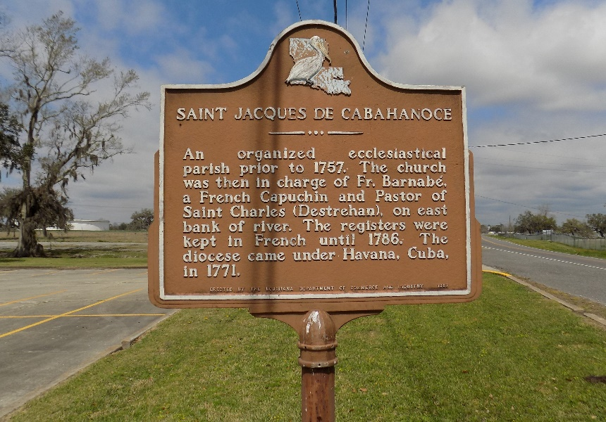

Geraldine DeBoue Mayho was born on June 3, 1943 in New Orleans, LA to the late Elijah Deboue Sr. and Jeanetta Patterson. Geraldine was called home to be with our Lord on Sunday, July 28, 2019 at 12:30 a.m. She was 76 years old. Geraldine was a native of New Orleans, LA and resided in St James, LA. She was a retired custodian with St James Parish School Board System.
Geraldine was the wife of the late Matthew Mayho. She is the mother of Kerry Johnson of Baton Rouge, LA, Torrell Mayho of St James, LA, Shondell Mayho of Pascagoula, MS, and the late Chevelle Phifer; Stepmother of Carolyn Landry (Leroy), Gale Farnell (Wayne), Wanda Adams (Gerald), Karen Batiste, and Christopher Mayho (Ernie); Sister of Lorena DeBoue, Jeannetta DeBoue Mary Louise DeBoue, Deborah Ann Watts, Alberta Christopher, Mary Ann Garrison, Lorraine Morgan (Perry), Leroy Deboue Sr., Thomas DeBoue, Edward DeBoue, and Larry DeBoue; Mother figure to her niece Trenise D. Murphy; Godmother of Tarneshria Scott and Charlene Scioneaux; Grandmother of 34 grandchildren, 37 great-grandchildren, and a host of nieces, nephews and friends.
In addition to her husband, daughter, and parents Geraldine was preceded in death by: Her stepsons David and Michael Mayho; siblings Audrey Patterson, Delores DeBoue, Elijah Mitchell DeBoue Sr. and Delores Martin; father and mother in law Romalice Mayho and Octavia W Mayho; brother and sister in laws Marshall Mayho, Mary Williams, Felonise Scioneaux, Mable Batiste, and Myrtle Weber.
Arrangements entrusted to Demby & Son Funeral Home. The family would like to thank everyone that took time out of their busy schedules to pray, call or visit in our time of sorrow.

Demby and Son Funeral Home, Donaldsonville, Louisiana

