Harold Joseph Mayo
September 28, 1935 – May 8, 2000

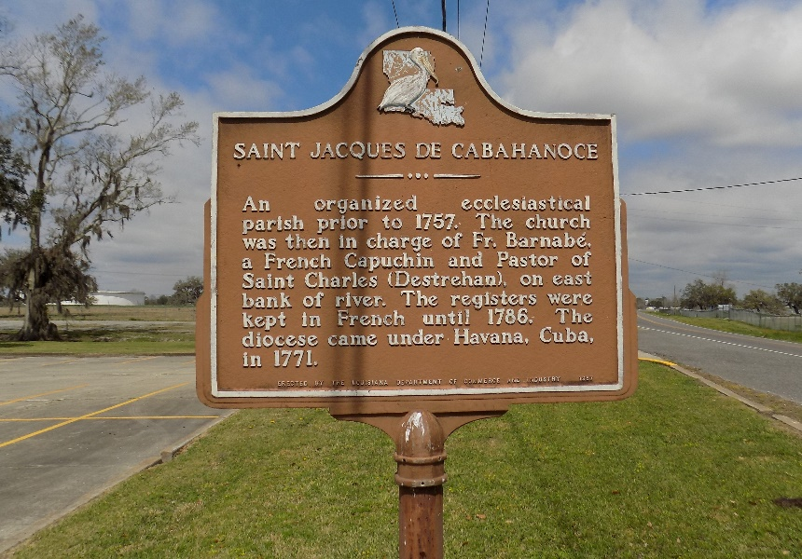

Harold ''Buttie" Joseph Mayo, 64, a native of St. James Parish and resident of Marrero, died May 8, 2000.
He was the father of Diedra Malveaux, Desise McCurdy and Dwayne, Darryl, and Dwight Mayo. He was the son of Foster and Vivian Mayo and brother of Florida Rodrigue, Betty Gibson, Angella Landry, Judy Gaudia and Melba, Claire, Robert, Clifford and Lester Mayo. He is also survived by eight grandchildren.
Services are today at 11 a.m. at St. James Catholic Church, St. James Parish, with interment in the church cemetery.

Unknown source
**

U.S., Veterans' Gravesites, ca.1775-2019

Name Harold Joseph Mayo
Death Age 64
Birth Date 28 Sep 1935
Death Date 8 May 2000
Interment Place Louisiana, USA
Cemetery Address 6613 Hwy 18 Saint James, La 70086
Cemetery St James Catholic Cemetery
Notes Us Army

