Clinton Melancon
October 8, 1956 – June 6, 2021

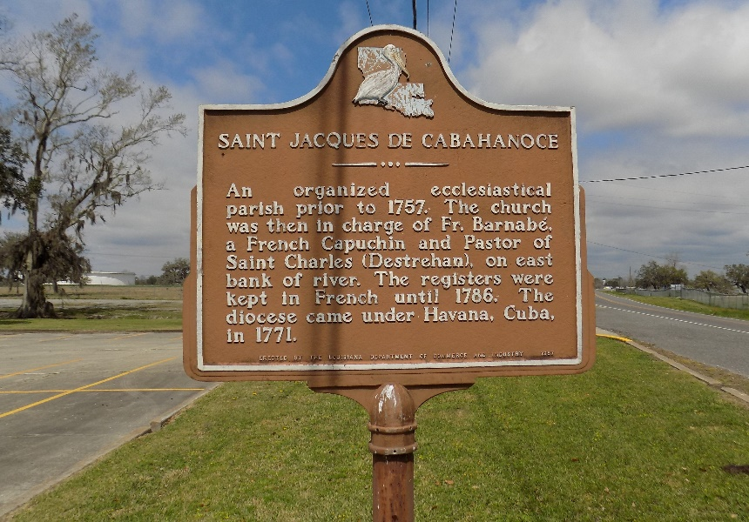

Clinton "Peanut" Melancon entered eternal life on Sunday, June 6, 2021 at the age 64. Clinton was born on October 8, 1956 in New Orleans, LA to Joseph Sr. and Flavia Melancon. He married Rita Charles Melancon on April 16, 1977.
Clinton was a General Foreman for many years at Iberville Insulation and transferred to Apache Industrial Company. He enjoyed fishing, hunting, gardening and hanging with family.
Clinton is survived by is his loving wife, Rita Melancon; children, Cornelius (Jennifer) Melancon, Shonnette (Chris) Whittington Sr., Clinton (Shardae) Melancon Jr., Juanques Melancon, Romell Howard Sr., Initius (Iman) Howard, and Tahajenik Melancon; 7 grandsons and 6 granddaughters, and host of nieces, nephews, cousins and friends.
He is preceded in death by his parents Joseph Sr. and Flavia Nash Melancon; 6 brothers, Joseph Jr., James, Glenn, Roland, Roy, and Barry Melancon and one sister Stella Castle.
A public walk-through visitation will be held on June 11, 2021 from 5pm-7pm at Treasures of Life Funeral Service, 315 E. Airline Hwy., Gramercy, LA. 70052. A mass of Christian burial will be held on Saturday June 12, 2021 at St. James Catholic Church Hwy. 18 St. James, LA 70086. Visitation from 9am-11am. Service will begin at 11am. Entombment to follow at St. James Catholic Church Cemetery.

Treasures of Life Funeral Services, Gramercy, Louisiana

