Roland Anthony Melancon
April 19, 1976 – April 2, 2016

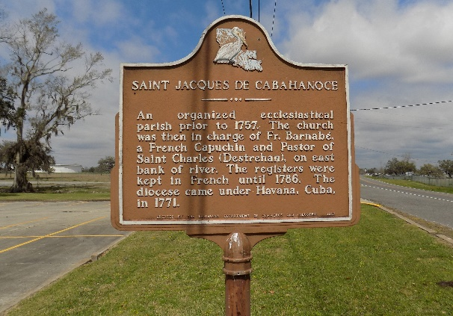

Roland Malancon – A native and resident of Vacherie, LA, was called home on, Tuesday, April 5, 2016. He was 63. Beloved husband of Josephine Malancon. Loving father of three daughters, Keisha, Raven, and Ashley Malancon and one son Daneiro Robiskie (Tangie) all of Vacherie, LA. Also survived by two grandchildren, Chase James, Jr. and Keishell Costly, one sister: Florence Roussell, six brothers: Royal, Raymond, Larry (Linda), Steve (Debra), Clinton (Rita), and Barry (Verlyn) all of Vacherie, LA, mother in-law: Elsie Dee Nelson of St. James, LA, one brother-in-law: Curtis Castle of Houma, LA, one sister-in-law: Shelia Melancon of Vacherie, LA. one aunt: Eva Mae Hall (Lawrence) of Avondale, LA. Memories will forever be treasured by sisters and brothers-in law, nieces, nephews, cousins, and friends.
He was preceded in death by his parents, Joseph Sr. and Flavia Nash Melancon; brothers, Joseph Jr., James and Glenn Melancon, and one sister: Stella Castle; Father in-law: Norward Nelson.
Relatives and friends are invited to attend visitation at Demby & Son Funeral Home, Donaldsonville, on Sunday, April 10, from 2- 4PM. Visitation continues 9 AM at St James Catholic Church, St. James until Mass of Christian Burial at 11AM, Rev. Chris Decker, celebrant. Recitation of the Rosary at 9:30 AM. Interment in the Church Cemetery, repast to follow at Church Hall.
Demby and Son Funeral Home, Donaldsonville, LA in charge of arrangements.

The Advocate, Baton Rouge, Louisiana
Apr. 9 to Apr. 12, 2016

