Royal Melancon
Abt. 1943 – October 26, 2016

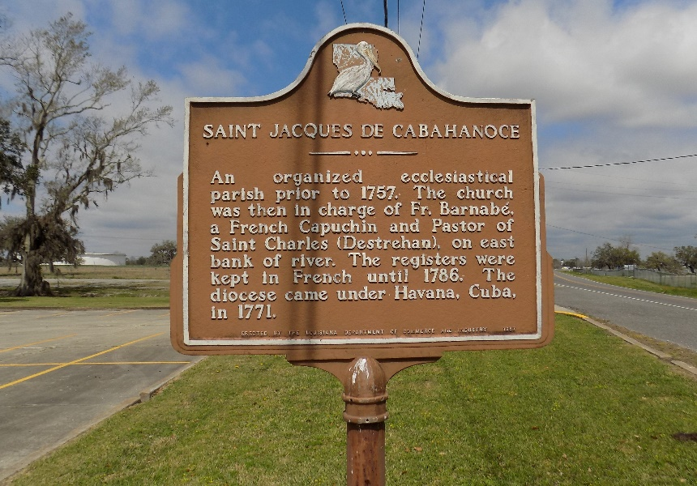

Royal "Roy" Melancon, age 73, a native and resident of Vacherie, Louisiana, entered into eternal life on Wednesday, October 26, 2016.
Visiting will be held on Wednesday, November 2, 2016 from 9:00am until the hour of service at 11:00am at St. James Catholic Church. Burial in the church cemetery.
He leaves to cherish his memories 2 sons, Alfred Smith, Jr. and Dion Melancon; 3 daughters, Jada and Cynthia Melancon and Shelcy (Murphy) Legaux; 5 brothers, Raymond, Larry (Linda), Steve (Debra), Clinton (Rita), Barry (Verlyn) Melancon; 1 sister Florence "Mice" Roussell; 11 grandchildren, 11 great grandchildren and host of nieces, nephews, other relatives and friends.
Preceded in death by his wife, Geraldine Jasmin Melancon; parents, Joseph and Flavia Melancon; 4 brothers, James, Roland, Joseph and Glenn Melancon, Sr.; 1 sister, Stella Melancon Castle; his mother-in-law, Sedonia Jasmin; father-in-law, Dewey Jasmin, Jr.; 3 sisters-in law and 1 brother-in-law.
Kennedy Funeral Home is in charge of arrangements, Lawanda Jasmin, Funeral Director.

The Advocate, Baton Rouge, Louisiana
Oct. 31 to Nov. 2, 2016

