Victorian Mitchell
March 27, 1912 – January 2, 2000

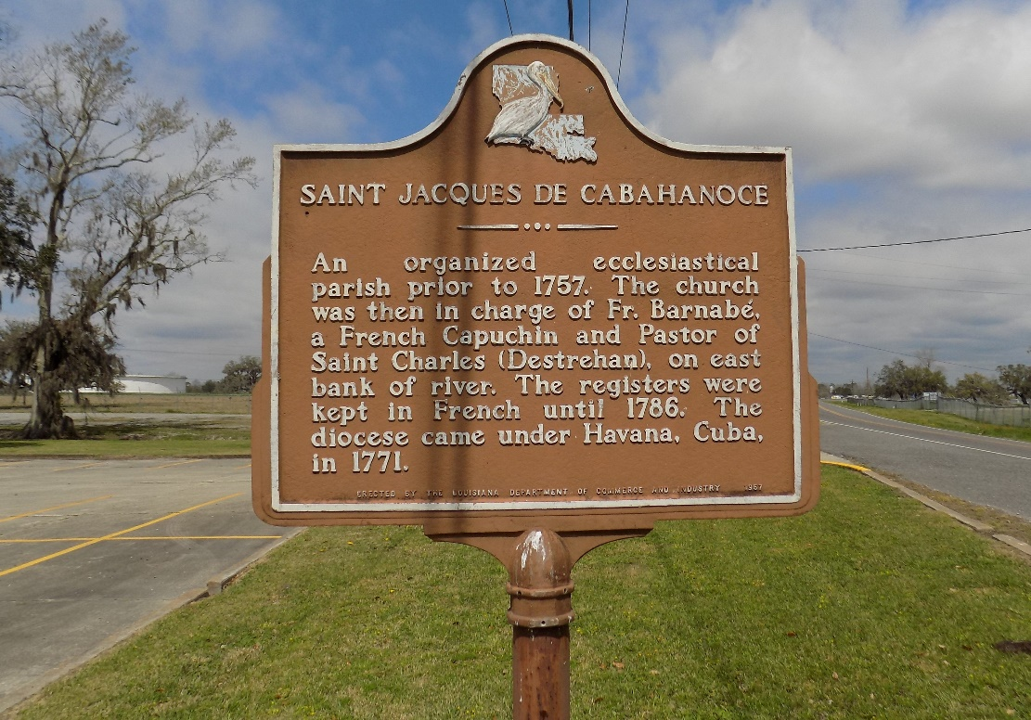

Victorian Mitchell, 87, a native of St. James, former resident of Baton Rouge, and resident of Lutcher, died Jan. 2, 2000. He was the husband of the late Theresa Momford Mitchell. He was the son of the late Elfair and Sedonia Morris Mitchell and brother of Florestine Adams, Phelonise Smith and the late Leon, Joseph, Webster and Andrew Mitchell.
Services are today at 11:30 a.m. at St. James Catholic Church, St. James, with interment at the church cemetery. Visitation starts at 9:30 a.m.

Unknown source
**

U.S., Social Security Applications and Claims Index, 1936-2007

Name Victor Mitchell
Gender Male
Birth Date 27 Mar 1912
Death Date 2 Jan 2000
Claim Date 24 Apr 1974
SSN xxx

