Bertell Stoney Moll Sr.
July 14, 1942 – July 19, 2016

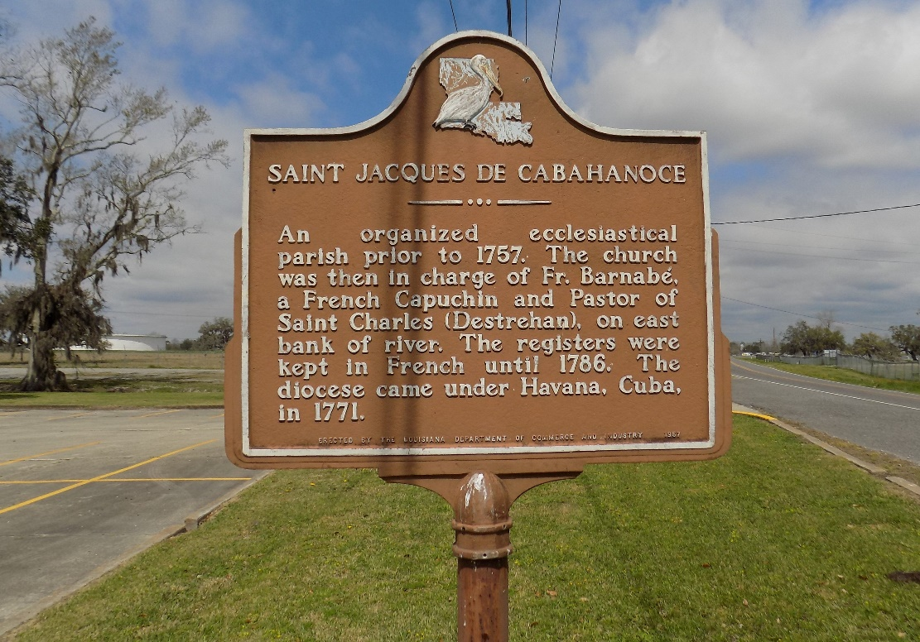

Bertell "Tony" Moll Sr. entered eternal life on Tuesday July 19, 2016. He was the devoted father of Dederie, Monica, Bertell Jr., and Jarvis Sr. (Shawna) Moll of St. James, La.

A Memorial Mass will be held on Wednesday July 27, 2016 for 11:00A.M. at St. James Catholic Church, 6618 Hwy 18 St. James, La. Rosary begins at 9:30 A.M. visitation for 10:00 A.M. Entombment St. James Catholic Church Mausoleum.

Treasures of Life - Center for Life Funeral, Gramercy, Louisiana

