Gloria (Champagne) Narcisse
July 14, 1942 – July 19, 2016

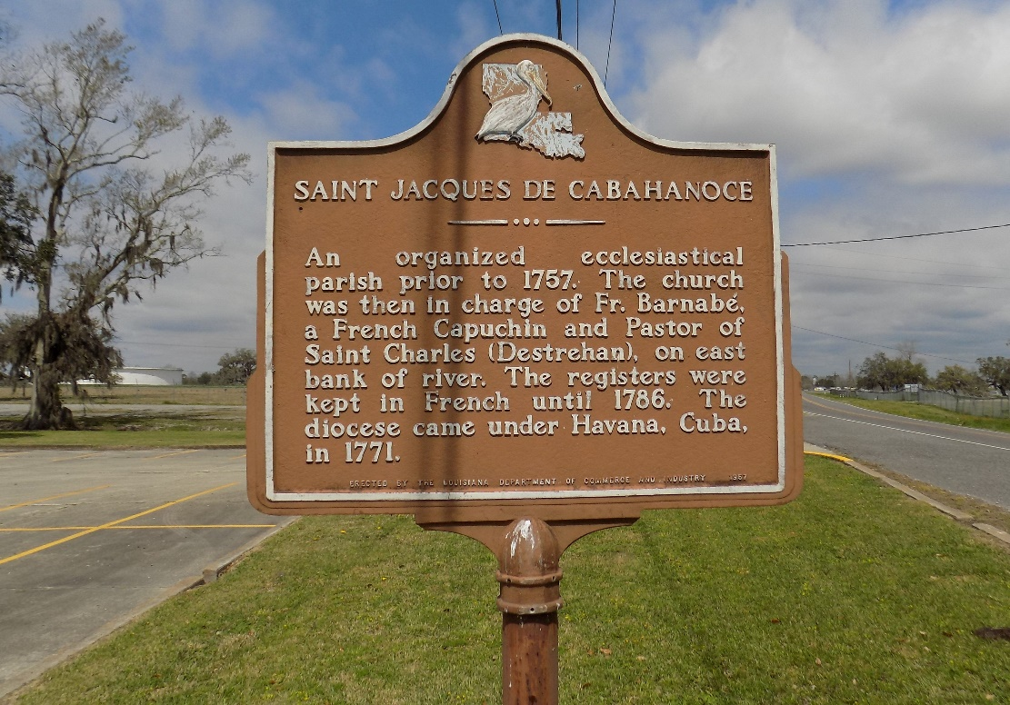

Gloria "Blackgal" Champagne Narcisse peacefully passed away on Friday, October 2, 2015, at the age of 64. Daughter of the late Annie B. Champagne.
Devoted wife of the late Rudolph Narcisse, Jr. Loving mother of Peggy (Evans) Joseph, Danielle Narcisse, Ronnie (Sabrina) Narcisse, Nicole Franklin and the late Seaneea Narcisse. Also survived by a host of sisters, brothers, grandchildren, nieces, nephews, other relatives and friends.
Funeral services will be held at St. James Catholic Church, 6613 Highway 18, St. James, LA, on Saturday, October 10, 2015, for 11:00 a.m. Visitation will be from 9:00 a.m. until time of service. Father Christopher Decker will be officiating. Interment will be at St. James Catholic Church Cemetery, St. James, LA.
The New Orleans Advocate (LA)
Oct. 8 to Oct. 10, 2015

