Nadine (Leonard) Nelson-Cooper
July 20, 1965 – April 29, 2024

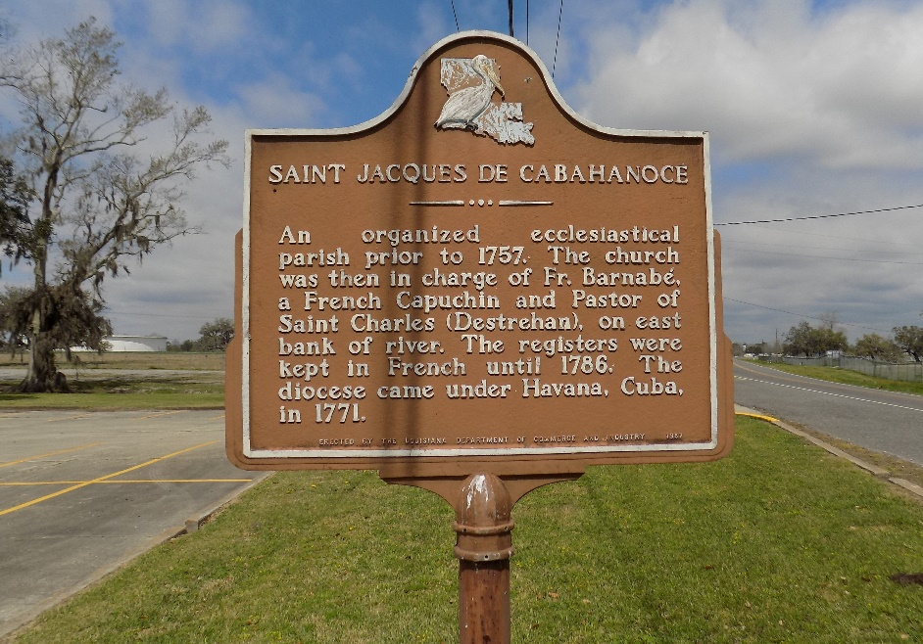

Nadine "The Boss" Nelson-Cooper, one who was loyal to her GOD, husband, child, family and friends, peacefully entered into eternal rest at the age of 58, on April 29, 2024. Nadine Nelson Cooper was born in New Orleans on July 20, 1965 to Berita Leonard.
She was joined in holy matrimony to Machiavelli Cooper on July 19, 1991. To this union their pride and joy was born, Nydia Maude Marie Cooper.
Nadine, was a lifelong resident and devoted community activist of St. James, LA. She was a parishioner of St. James Catholic Church, a member of the 5th Ward District on the Move, which including organizing events for the youth as well as senior citizens in the St. James community and the Director of the 5th District Summer Camp. She was a dedicated educator for over 30 years, serving children and families in St. James Parish and Lafourche Parish School Systems.
Nadine's love for photography started at an early age. She developed her craft in college by enrolling in courses to learn many techniques. From this love, she started A Class Act Photography, where she strived for perfection by taking many, many pictures until she was pleased with what she captured.
She leaves her love and legacy to her pride and joy, Nydia Maude Marie Cooper; her husband, Machiavelli Cooper; mother, Berita Leonard; brother, George Leonard; one sister in law, Eliska Cooper of St. James; four brother in laws, Mark (Lois) Cooper, Sr. and Raffeal (Alfreda) Cooper of St. James, Darwin (Tonja) Cooper of Baton Rouge, and Wilfred Wayne (Lisa) Cooper, Sr. of Greensburg, LA; Special cousins who were more like siblings, Junius Julien, Jr. (Charlene), Joachina (Sam) Robertson and Joseph Julien. She was affectionately known as a second mom to Tremeka Lewis, Johannces Baptiste, Trevor and Travis Nelson, Dr. Latricia Blain, Denishia Steib, Angela Trevino and Jamal Sharis. Nadine was reared by her loving and devoted aunt Maude Winchester and uncles, Murphy (Banks), and Junius (Te Calais) Winchester.
She was preceded in death by her aunt, Maude Winchester; two uncles Murphy and Junius Winchester; Father and Mother-in-law, Wilfred and Dora Cooper; and sister-in-law, Merita Cooper.
A Mass of Christian Burial will be held on Friday, May 10, 2024, at St. James Catholic Church, 6613 LA-18, Saint James, LA 70086. At the family's request, there will be NO viewing of the remains. Only a visiting period with the family which will begin at 12PM with the Mass to follow at 2PM. Interment at St. James Catholic Church Cemetery.

Treasures of Life Funeral Services, Gramercy, Louisiana

