Rebie (Morris) Nelson
August 23, 1919 – April 7, 2000

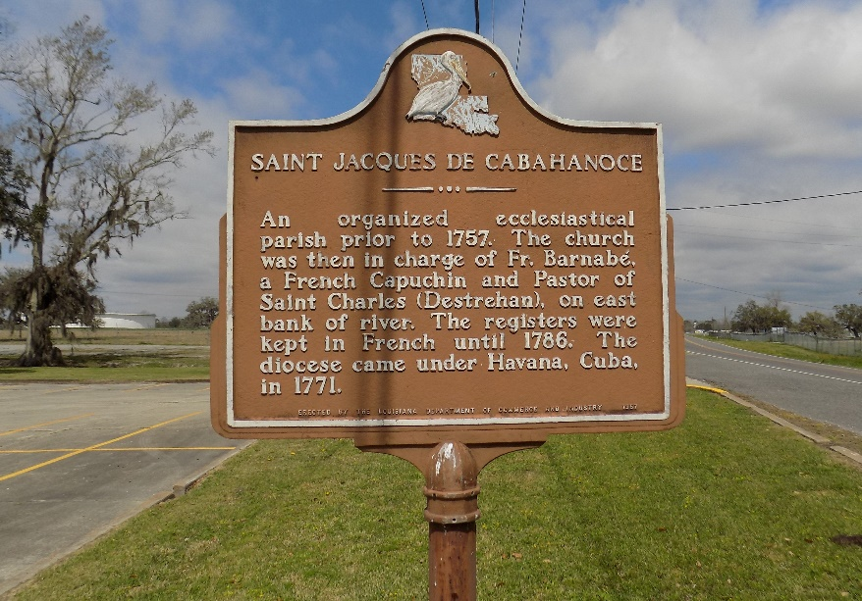

NELSON AMA – Rebie Morris Nelson, 80, native of St. James Parish and resident of Ama, died April 7. She was the wife of Richard Nelson and mother of Peggy Baker, Patricia Nelson, Barbara Arthur and Yvonne Paylor. She was also the daughter of the late Felix and Lucille Morris and sister of the late Marie Villavaso.
She is also survived by seven grandchildren. Services are today at 11 a.m. at the St. James Catholic Church, St. James, with interment at the church cemetery. Visitation starts at 10 a.m.

L’Observateur, LaPlace, Louisiana
April 11, 2000
**

U.S., Social Security Death Index, 1935-2014

Name Rebie M. Nelson
Social Security Number xxx
Birth Date 23 Aug 1919
Issue year 1966
Issue State Louisiana
Last Residence 70031, Ama, Saint Charles, Louisiana, USA
Death Date 7 Apr 2000

