Richard Matthew Nelson
1918 – May 17, 2006

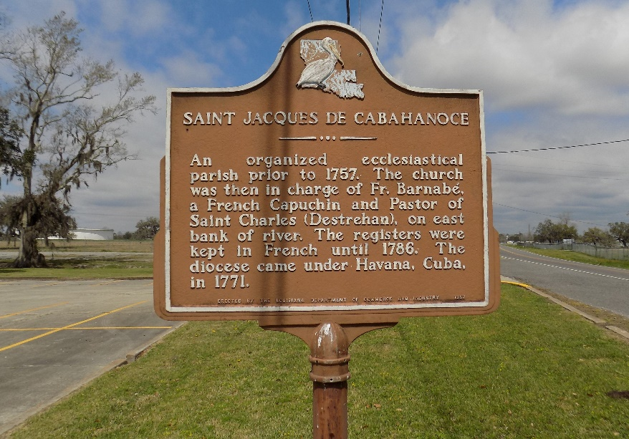

Richard Matthew 'Toe-Toe' Nelson, age 87 years, a World War II Veteran and retired steel fabrication for Orleans Material and Equipment Company, departed this life at his residence in Ama, LA on Wednesday, May 17, 2006.
Son of the late Louis Nelson and Jeanne LaCroix Johnson. Beloved husband of the late Rebie Morris Nelson. Father of Peggy Nelson Baker and Patricia Rose Nelson of New Orleans, LA; Barbara Nelson Arthur of Peachtree City, GA and Yvonne Nelson Paylor of Hillsborough, NC. Brother of the late Alexander Johnson, Claude Washington and Nolia Young Johnson.
Deceased is survived by seven grandchildren and two great grandchildren, a host of nieces, nephews, godchildren, relatives and friends. A native of St. James, LA., a former resident of New Orleans, LA and a resident of Ama, LA.
Relatives and friends of the family, also priests and parishioners of St. Mark Catholic Church, Ama, LA and St. James Catholic Church, St. James, LA; Rising Sun Benevolent Association; Knights of Peter Claver, Council #21; Knights of Columbus, Council #2409; Msgr. Paul J. Richard Knights of Columbus, Assembly #2053; employees of Orleans Material and Equipment Company; J.M. Waller Associates, Inc. and Installation Management Agency, Army Reserve Office, College Park, GA; Blue Cross Blue Shield of North Carolina; Office of Family Support; University of New Orleans, English Department and New Orleans Country Club are invited to attend a viewing and recitation of the rosary at St. Mark Catholic Church, 10771 River Road, Ama, LA. on Sunday, May 21, 2006, from 5:00 to 7:00 p.m. Father Joseph Dau Van Nguyen, Pastor. Mass of Christian Burial at 11:00 a.m. on Monday, May 22, 2006 at St. James Catholic Church, 6613 Highway 18, St. James, LA. Viewing from 9:00 a.m. until service. Father Louis T. Oubre, Celebrant and Father Joseph Dau Van Nguyen, Co-celebrant. Interment in St. James Catholic Church Cemetery.

Times Picayune, New Orleans, Louisiana
May 21, 2006

