Victor Joseph Nelson Jr.
February 13, 1947 – April 22, 2024

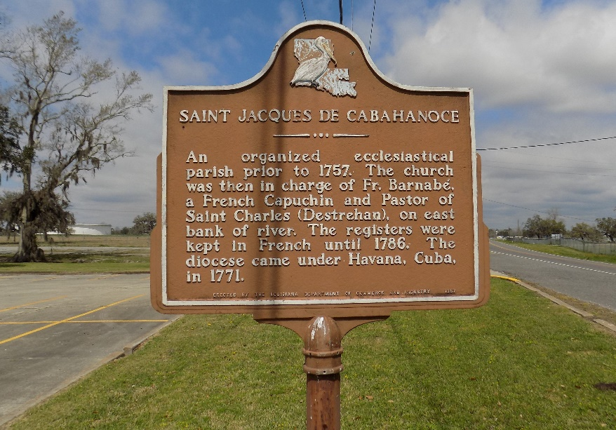

Victor J. Nelson, Jr. entered into eternal rest on Monday April 22, 2024, at the age of 77. He was a native and resident of New Orleans, LA. Victor was a retired crane operator with Orleans Material.
Beloved father of Carlette Nelson Anderson and Victor Nelson. Son of the late Victor J. Nelson, Sr. and Eunice W. Nelson. Brother of Berita Nelson Leonard and the late Andrew J. Nelson, also survived by 3 grandchildren, 8 great grandchildren, and a host of nieces, nephews, cousins, other relatives, and friends.
Relatives and friends of the family, also priest and parishioners of St. Maria Goretti Church and all neighboring churches are invited to attend the Mass of Christian Burial at St. Maria Goretti Church 7300 Crowder Blvd. New Orleans, LA on Saturday, May 11, 2024, at 11:00a.m. Visitation will begin at 10:00a.m. until service time at the church. Interment: St. James Catholic Church Cemetery-St. James, LA.

Davis Mortuary Service, Gretna, Louisiana

