Eddie James Nicholas
June 24, 1926 – May 12, 2004

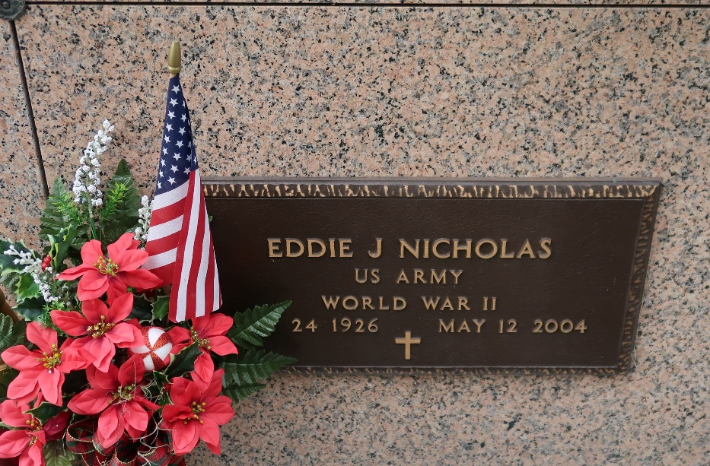

Eddie J. Nicholas, on Wednesday, May 12, 2004 at Thibodaux Regional Medical Center at 12:30 a.m. Husband of Anna Belle Nicholas. Son of the late Clifford and Gustavia B. Nicholas. Father of Lucretia Nicholas, Nina (Charles) Nailor of St. James, LA. and Charmaine (Michael) Williams of Dallas, TX. Brother of Eddis Nicholas of St. James, Stella Johnson of Marrero, Clifford and Lawrence Nicholas of Marrero. Also survived by (6) grandchildren, (4) great grandchildren, sisters-in-law and brothers-in-law, a host of nieces, nephews, cousins and friends. A native and resident of St. James, LA. Age 77 years.
Relatives and friends of the family, also priest and parishioners of St. James Catholic Church and neighboring churches, members of Rising Sun Benevolent Society and Pride of Brookstown Society, Employees of St. James Parish School System, Shell Pipeline are invited to attend a Mass of Christian Burial on Saturday, May 15, 2004 at 11:00 a.m. from the St. James Catholic Church, St. James, LA. Father Louis Oubre, celebrant. Visitation at the church after 9:00 A.M. on Saturday. Entombment Church Mausoleum. The Baloney Funeral Home in charge of arrangements.

The Times-Picayune, New Orleans, Louisiana
May 14, 2004

