Herman H. Nicholas
1928 – March 10, 2024

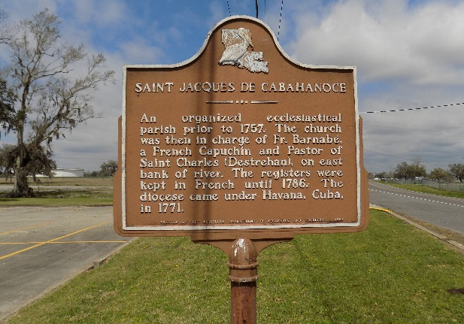

Herman H. Nicholas “Brother-in-law” departed this life on Sunday, March 10, 2024, at The Crossing at Clarity Hospice in Baton Rouge, LA. He was 96, a native of St. James. LA and resident of Donaldsonville, LA.
Visitation on Saturday, March 23, 2024, at St. Catherine of Sienna of Catholic Church, 421 St. Patrick St., Donaldsonville, LA from 9:00am to Mass of Christian Burial at 11:00am. Interment in St. James Catholic Church Cemetery.
Survived by his daughter and caregiver, Chantay Nicholas; stepson, Michael Cayette (Rutha); 2 sisters, Edna Mae Mathieu, and Lucille Marie Alexis; 3 grandchildren, Royetta Gibson (Michael, Sr.), Jimonique Southall, and Latavia “Tay Tay” Nicholas; 3 great grandchildren, Michael, Jr, Imani, and Milania Gibson; a host of nieces, nephews, other relatives, and friends.
Preceded in death by both wives, Betty LeBlanc Nicholas, and Lois Julien Cayette; his parents, Julia, and Carol Nicholas; 1 daughter, Cheryl Ann Nicholas; 1 stepson, Leroy Cayette; 1 sister, Louise Sims; 5 brothers, Russell, Sr., Warren, Earl, Harry, and Carol Nicholas, Jr.

Williams & Southall Funeral Home, Donaldsonville, Louisiana

