Lynn Nicholas Jr.
1947 – October 20, 1919

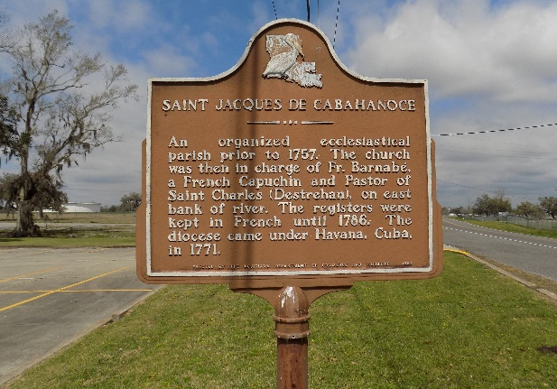

Lynn “T-Lynn” Nicholas, Jr. departed this life on Sunday, October 20, 2019 in Lewisville, TX. He was 72, a native and resident of St. James, LA.
Visitation on Friday, October 25, 2019 at Williams and Southall Funeral Home, 101 Loop 945, Donaldsonville, LA from 4:00pm to 6:00pm. Visitation at St. James Catholic Church, St. James, LA on Saturday, October 26, 2019 from 10:00am to Mass of Christian Burial at 12:00pm. Burial in the Church Cemetery.
Survived by his wife, Dianne M. Nicholas; 1 son, Dontrell Nicholas (Kimberly); 1 daughter, Danitra Nicholas Smith (Norman); niece, Carla Weber Borne; nephew, Clyde Weber, Jr.; 2 grandchildren, Makayla Manigault and Noel Smith; a host of nieces, nephews, other relatives and friends.
Preceded in death by his parents, Ida and Lynn Nicholas, Sr.; 1 sister, Carolyn Weber; maternal and paternal grandparents.

Williams & Southall Funeral Home, Donaldsonville, Louisiana

