Ronald J. Nicholas Sr.
1942 – February 27, 2018

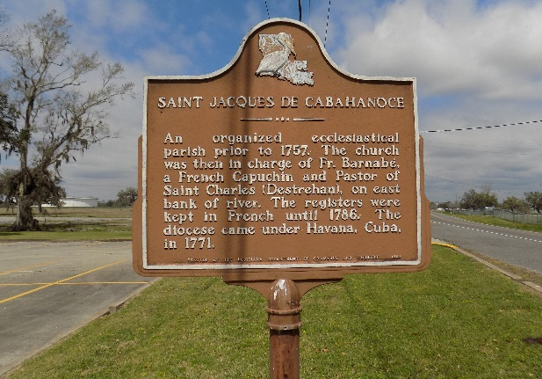

Ronald J. "Rabbit" Nicholas, Sr. departed this life on Tuesday February 27, 2018 at St. Elizabeth Hospital, Gonzales, LA. He was 65, a native and resident of St. James, LA.
Visitation on Saturday, March 10, 2018 at St. James Catholic Church, St. James, LA 9:00am to Mass of Christian Burial at 11:00am. Burial in the Church Cemetery.
Survived by 1 son, Ronald Nicholas, Jr.; 1 daughter, Ina Nicholas; 3 brothers, Gerald (Sharon), Russell and Kenneth (Alfreda) Nicholas; 3 sisters, Cynthia Jones (Cornell), Judith Morris and Carolyn Landry (Kerry); a host of aunts, uncles, nieces, nephews, other relatives and friends. Preceded in death by his parents, Ida and Russell Nicholas.

Williams & Southall Funeral Home, Donaldsonville, Louisiana

