Willis Anthony Octave Sr.
July 19, 1930 – February 25, 2021

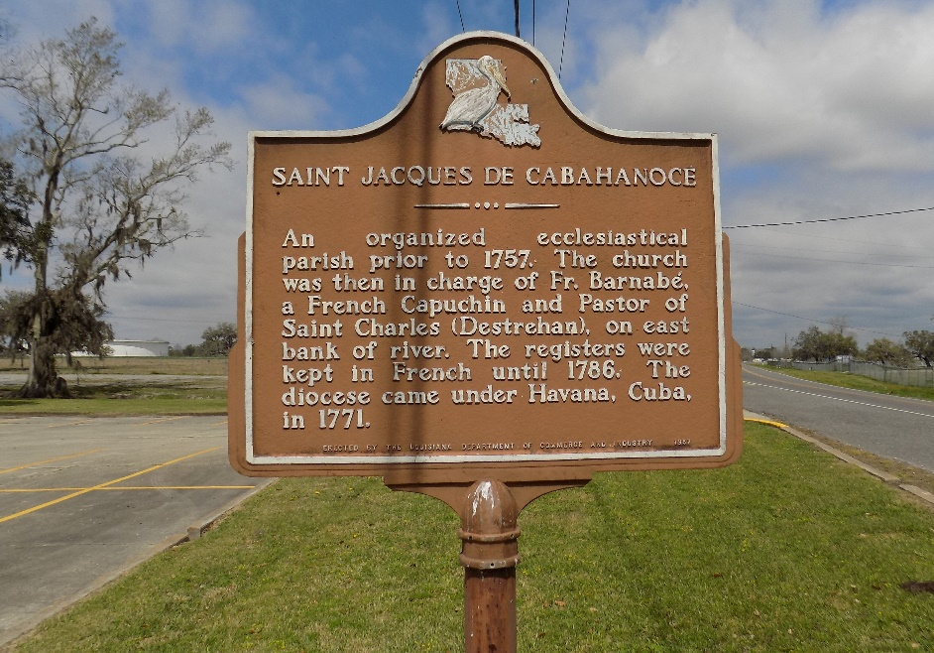

Willis Anthony Octave Senior, beloved Husband, Father, Grandfather, Brother, and Friend, departed this life on February 25, 2021, at the age of 90 years old. Willis was born on July 19, 1930, to the late Arthur and Alverine (Pierre) Octave. He was a lifelong resident of St. James, La.
Willis was a parishioner of St. James Catholic, where he was a member of the Knights of Peter Claver for over 60 years. Willis was a devoted educator, serving the children of St. James as a teacher, principal, administrator, and school board member. He was also a member of Rising Sun Benevolent Association, Welcome Senior Center, and proudly served his country in the U.S. Army. Willis was a member of the Phi Beta Sigma fraternity pledging at his beloved Xavier University.
Willis is survived by his wife of 64 years, Regina (Oubre) Octave; 5 children – Wendell Kimball Octave, Karisue (Ricky) Nelson, Willis (Billy) Jr (Daphne) Octave, Lansing (Michelle) Octave, and Shannon (Shantel) Octave; 13 grandchildren; 11 great grandchildren; brother Arthur (Delores) Octave; and a host of relatives and friends.
Willis was preceded in death by his parents, Arthur and Alverine Octave; sister and brother in law Mildred and Joseph Whittington Sr. Willis leaves behind a legacy of faithful service to his community and parish. He touched many lives and was a community activist for equality in education. Willis was respected by all and will be sadly missed by family and friends.
Visitation will be on Wednesday, March 3, 2021, from 5pm to 7pm at Demby and Son Funeral Home. A Mass of Christian Burial will be held on Thursday, March 4, 2021, at St James Catholic Church with the rosary being recited at 10:30 am followed by mass at 11 am. Due to covid 19, masks and social distancing will be required. Please visit www.dembyandson.com to sign the guestbook.

Published by Legacy Remembers from Mar. 2 to Mar. 4, 2021

