Julie David Ordoyne
January 6, 1953 - January 19, 2025

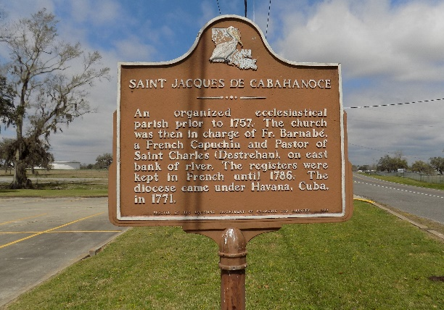

Julie David Ordoyne, beloved wife and mother, of St. James, LA, passed away on January 19, 2025, leaving a void her family cannot fill.
Julie is survived by her children, Danielle Ordoyne, Henry Ordoyne III, Cindy Ordoyne (John), Chad Ordoyne (Melony), and Jason Glaviana. Grandchildren Hunter Perez, Gracie Theriot, Zachary and Ashley Glaviana. Brother Frank Musso (Patricia), Sister Crystal Faucheux (Glenn) ,Brother-in-Law Claude Ordoyne (Faye), Sister-in-law Marie Holdum and countless nieces and nephews. All of whom will never forget the love she brought to their lives.
Julie took special joy in her love for history and tending to her house plants. She would gladly give anyone lessons on the history of St. James Parish, the Acadian people and the genealogy of her family.
Julie was preceded in death by her loving husband Henry Ordoyne Jr., Father Julian David, Mother Ruby Leblanc Chiasson, Stepmother Loraine David, Stepfather John V. Chiassion, Grandparents Joe and Anna Leblanc, Mother-in-law Marie Ordoyne, Father-in-law Henry Ordoyne Sr., Sister Joanna Brewer, Brother-in-law Earl Brewer, Nieces Tracey and Bridget Brewer, and Brother-in-law Billy Holdum, and her beloved dog Boo-Boo.
Relatives and friends are invited to attend the Visitation and Funeral Mass on Saturday, January 25, 2025 at St. James Catholic Church,6613 LA-18, St James, LA. Visitation from 11:30 am till 1:00 pm, followed by the Funeral Mass at 1:00 pm. Entombment will immediately follow the Mass at St James Catholic Cemetery.

Rose Lynn Funeral Home, Lutcher, Louisiana
January 23, 2025

