Marie (Tabor) Ordoyne
February 25, 1926 – March 31, 2005

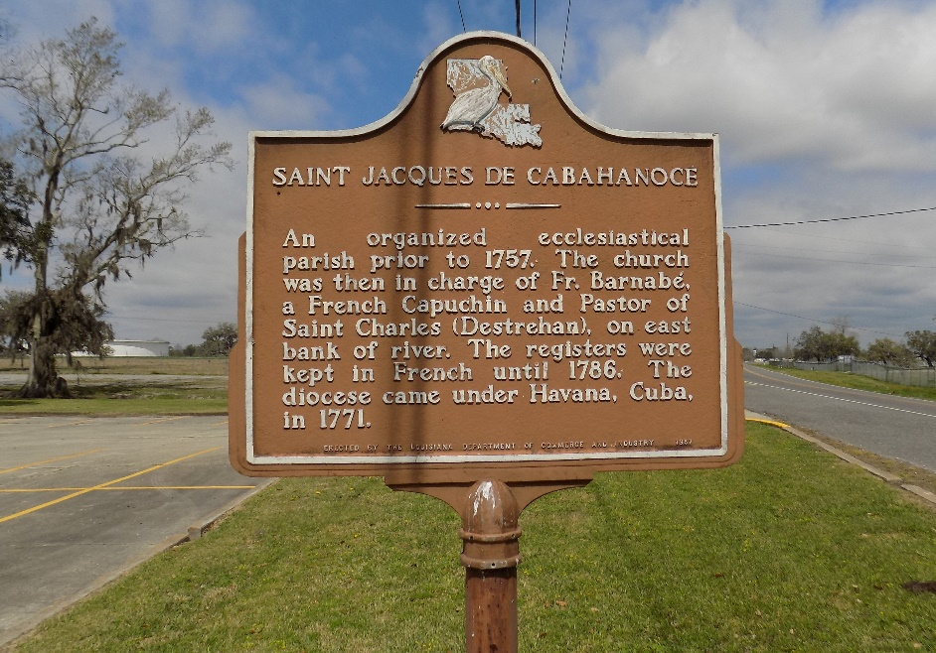

Ordoyne, Marie Tabor - A homemaker and lifelong resident of St. James, she died at 6:25 p.m. Thursday, March 31, 2005, in Gonzales. She was 79 and a native of Thibodaux.
Visiting at St. James Catholic Church, St. James, from 9 a.m. until religious service at 11 a.m. Saturday, April 2, conducted by the Rev. Louis Oubre. Interment in church cemetery.
She is survived by a daughter, Marie Hodum, Gonzales; two sons and daughters-in-law, Henry Ordoyne Jr. and Julie Ordoyne, St. James, and Claude and Faye Ordoyne, Prairieville; two brothers, Philip Tabor, St. James, and Wilford Tabor, Choctaw; 10 grandchildren and 11 great-grandchildren.
Preceded in death by her husband, Henry Joseph Ordoyne Sr.; parents, Clovis and Theresa Tabor; a son, Thomas Paul Ordoyne; a son-in-law, Billy Hodum; four sisters and four brothers. Ourso Funeral Home, Gonzales, is in charge of arrangements.

The Advocate, Baton Rouge, Louisiana
Apr. 2, 2005

