Ethel (Zeringue) Oubre
November 10, 1932 – January 5, 2024

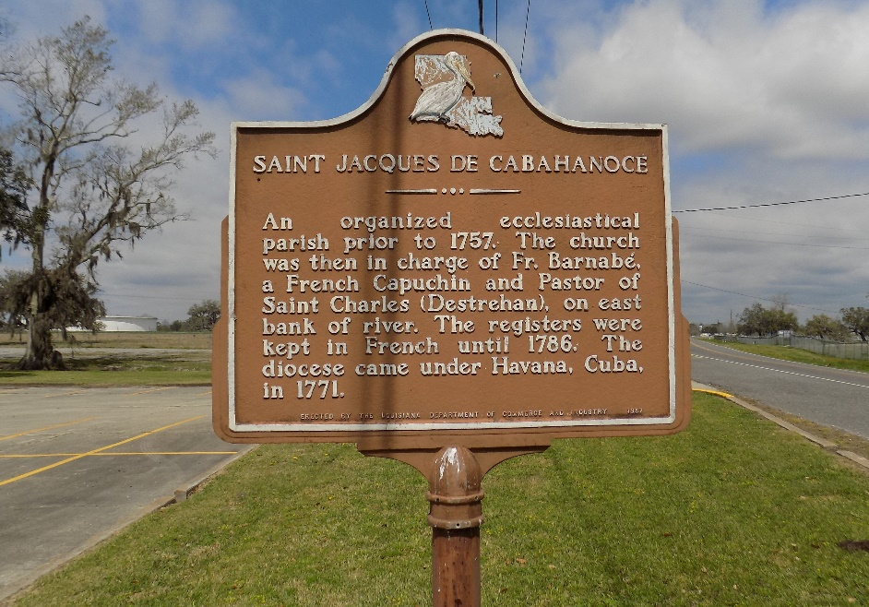

Ethel "Totsy" Zeringue Oubre, a native of St. James and a resident of Donaldsonville passed away Friday, January 5, 2024, at the age of 91. She is survived by her children Dolores Oubre, Ramona Martin, Robin Borne (Douglas), David Oubre (Catherine), Gerard Oubre (Toni Ourso); 9 grandchildren, 27 great-grandchildren and sister Lillian Ledet.
She is preceded in death by her loving husband Hernest J Oubre, parents Albert Sr. and Regina Zeringue, grandson Cory Oubre, great-grandson Colton Martin, sisters Aline Becnel, Anna Mae Ledet, Therese Folse and brother Albert Zeringue Jr.
She cherished the time spent with her family. The highlight of any day was when she could rock the babies. She also had a passion for cooking, especially Sundays and holidays when her family would all gather. She passed down many of her favorite recipes with her fruit cakes, pralines and tea cookies the best around.
The family would like to thank the staff of Lakeview Regional Medical Center (Covington) and Compassus Hospice (Covington) for the exceptional care given to their mom. They would also like to thank the staff of Chateau D'ville Rehab and Retirement for the care their mom received.
Visitation will be at St. James Catholic Church on Wednesday, January 10, 2024 from 9:00 am to 11:00 am followed by a Funeral Mass of Christian Burial. She will be laid to rest in the church cemetery.

The Advocate, Baton Rouge, Louisiana
January 7-9, 2024

