Hernest Jean Oubre
June 29, 1924 – April 9, 1981

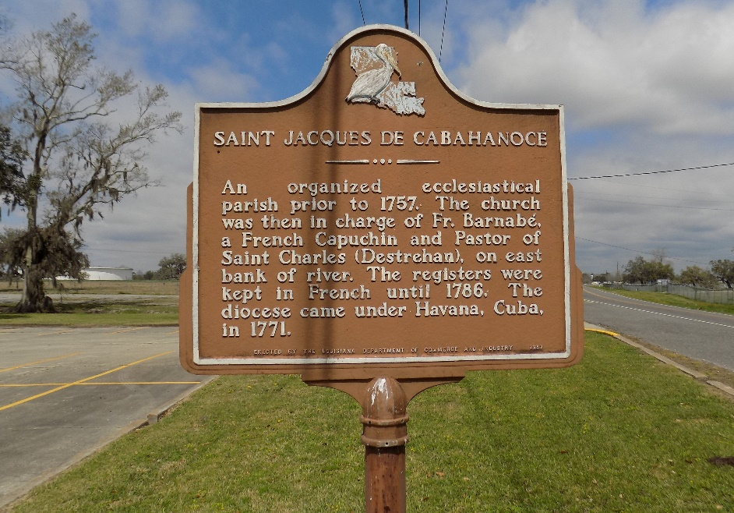

Hernest J. Oubre, died at his residence in Saint James on Thursday, April 9, 1981, at 6:15 pm. Son of the late Mr. and Mrs. Therence Ourbe, husband of Ethel Zeringue Oubre, father of Mrs. Robin Borne, Ramona, and Delores Oubre, and Gerard Oubre, all of St James; David Oubre, Donaldsonville. Brother of Mrs. Celie Chenier of Saint James, Calvin Oubre of Metairie, Mrs. Shirley Simon, Mrs. Mildred Landry, Mrs. Glades Becnel, Jessie, Roland, and Clemence Oubre, all of Vacherie. Also survived by four grandchildren. Age 56 years, a native of Vacherie and a resident of St. James.
Relatives and friends of the family were invited to attend the funeral services from the Knights of Columbus Home in Vacherie on Saturday, April 11, 1981, at 9:30 am followed by Religious services at St. James Catholic Church, in Saint James at 10:00 am. Entombment in church cemetery.
Caballero Funeral Home, Donaldsonville, in charge of the arrangements.

The Enterprise, Vacherie, Louisiana
April 14, 1981

