Catherine (Oubre) Pedescleaux
October 27, 1944 – April 3, 2008

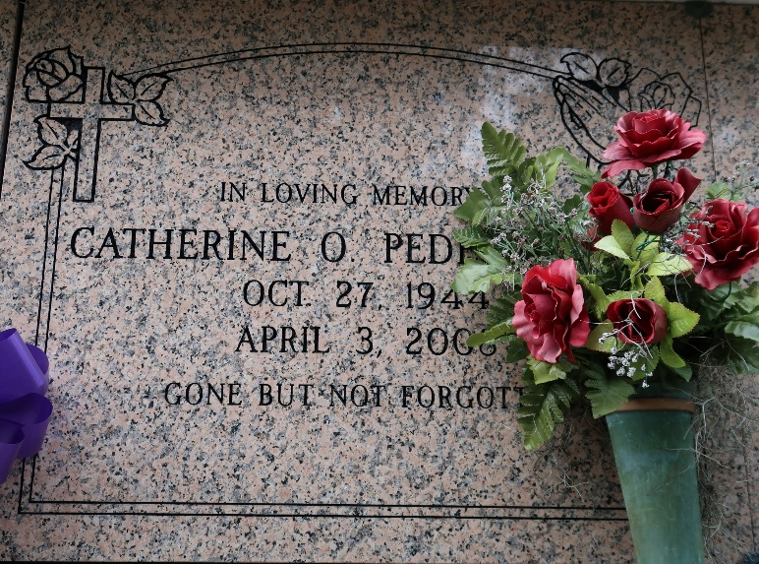

CATHERINE OUBRE PEDESCLEAUX - On Thursday, April 3, 2008 at St. Elizabeth Hospital. Wife of Oscar Pedescleaux, Sr. Mother of Oscar, Jr. and Damian Pedescleaux. Daughter of the late Freddie and Pauline Oubre. Sister of Freddie, Jr. and Raymond Oubre and the late Michael Oubre. Also survived by two grandsons and a host of sisters in law, aunts, uncles, nieces, nephews other relatives and friends. A native and resident of St. James Parish. Age 63 yrs.
Mass of Christian Burial on Tuesday, April 8, 2008 beginning at 11:00am from St. James Catholic Church, 6613 Hwy 18, St. James, La. Rev. Louis Oubre, Celebrant. Entombment in the church mausoleum. Visitations from 8:30am to Mass time on Tuesday at the church.

Williams & Southall Funeral Home, Assumption Parish, Louisiana
**

U.S., Newspapers.com™ Marriage Index, 1800s-current

Name Mr Oscar J Pedescleauz
Gender Male
Marriage Date 12 Feb 1972
Marriage Place Vacherie
Parents Pedescleauz
Spouse Catherine Natalie Oubre

