Oscar Joseph Pedescleaux Sr.
1943 – October 16, 2021

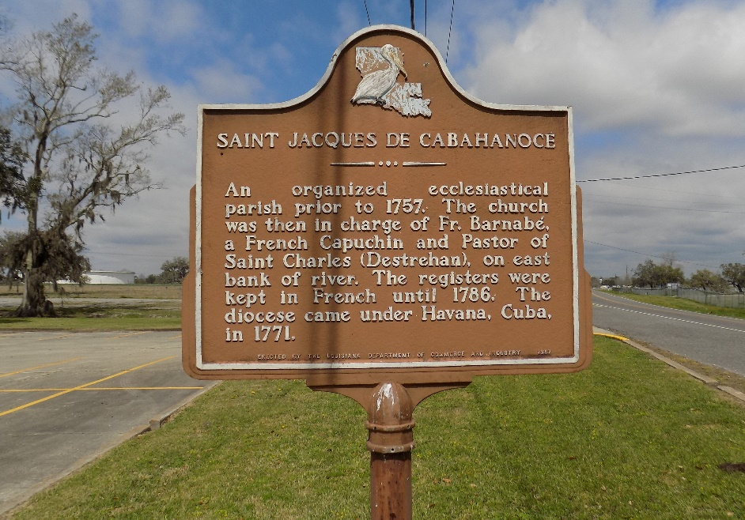

Oscar Joseph Pedescleaux, Sr. departed this life on Saturday, October 16, 2021 at his residence in St. James, LA. He was 78, a native of St. James, LA.
Visitation on Friday, October 22,2021 at Williams and Southall Funeral Home, 101 Loop 945, Donaldsonville, LA from 2:00pm to 4:00pm. Visitation on Saturday, October 23, 2021, at St James Catholic Church from 11:00am to Mass of Christian Burial at 1:00pm. Burial in the church cemetery.
Survived by 2 sons, OJ and Damian; 2 Daughters-in-law, Kadrian Pedescleaux and Dr. Stacy Pedescleaux; 3 sisters, Emelda Pedescleaux, Mary Wallace, and Rose Weber; 2 Brothers-in-law, Freddie Oubre, Jr., and Benton Weber; 1 Sister-in-law, Bernadette Oubre; 4 grandchildren, Kameron Pedescleaux, Devin Pedescleaux, Kenley Pedescleaux, and Grace Pedescleaux; a host of nieces, nephews, other relatives and friends.
Preceded in death by his parents, Gustave and Margaret Pedescleaux, wife Catherine Pedescleaux, brothers-in-law, Joe Wallace, Sr., Michael Oubre, Raymond Oubre, and sisters-in-law, Amanda Oubre and Marie Oubre.

Williams & Southall Funeral Home, Donaldsonville, Louisiana

