Marilyn (Steib) Pierre
1954 – July 29, 2013

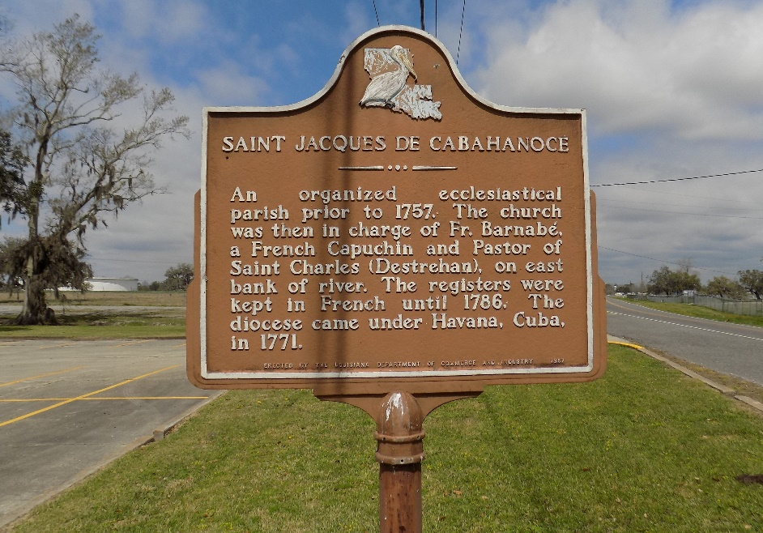

Marilyn Steib Pierre, passed away on Monday, July 29, 2013, at the age of 59 years old. Daughter of the late Theresa and Murphy Steib, Sr. Wife of the late Alex Pierre, Jr. Mother of Zeakea (Timothy) Dumas, Schonette and Krystle Pierre. Grandmother of Shonay and Salaya Pierre, Zyria Dumas, and Pierre Meyers. Sister of Ruby Joseph, Theresa (Earl) Tassin, Murphy (Beatrice) Steib, Jr., Lisa (Gary) Washington and the late Maxine Clarence, Gail Rodney and Gladys Becnel. Daughter-in-law of the late Elex and Fabiola Pierre, Sr. Sister-in-law of Ellis Becnel, Sr., Stanley Rodney, Sr., Stanford Jeffery, Sr., Marion Williams, Joyce (Edmond) Morton, Sr., Rev. Douglas (Wanda) Pierre, Shelia Melancon, Bernard Pierre, Michael (Quinna) Pierre, Richard (Wanda) Pierre, Kathleen Pierre (Clarence Williams), Jerome Pierre, and the late Deloris Jeffery. Also survived by a host of aunts, uncles, nieces, nephews, other relatives and friends.
Funeral services will be held at St. James Catholic Church, 6613 Highway 18, St. James, La. on Monday, August 5, 2013, for 10:30 a.m. Visitation will be from 9:00 a.m. until time of service. Father Christopher Decker will be officiating. Interment will be at St. James Catholic Church Cemetery, St. James, LA.
The Times-Picayune, New Orleans, Louisiana
Jul. 31 to Aug. 4, 2013

