Barbara (Heary) Poche
1949 – February 9, 2014

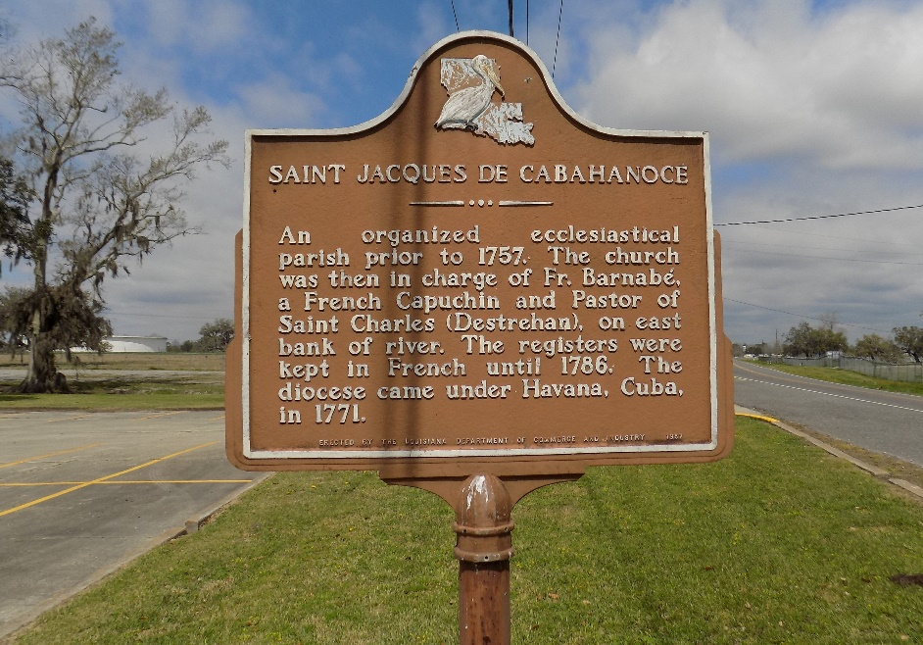

Barbara Heary Poche entered into eternal rest on Sunday, February 9, 2014, at the early age of 64 years old. Devoted wife of Lawrence Poche, Jr.
Forster mother of Valerie, Shelia, Sam and April Jackson. Sister of Amelia H. Henderson, Lydia H. Stewart, Yvonne H. Green, Patricia H. (Louis) Schexnayder, Sr., and Betty H. Stewart. Godmother of Karen M. Batiste, Monica Schexnayder, and Cameron Stewart. Also survived by a host of aunts, one uncle, sisters-in-law, brother-in-law, nieces, nephews, cousins, other relatives, and classmates.
Relatives, classmates, friends and employees of St. James Parish School Board are invited to attend a Mass of Christian Burial on Friday, February 14, 2014, at 11:00 a.m. at St. James Catholic Church, 6613 Highway 18, St. James, LA. Father Christopher Decker will be officiating. Visitation will be from 8:30 a.m. until the time of service. Interment will be at St. James Catholic Church Cemetery, St. James, LA.
The New Orleans Advocate, Louisiana
Feb. 12 to Feb. 13, 2014

