Byron Dale Poirrier Jr.
February 22, 1964 – September 7, 2019

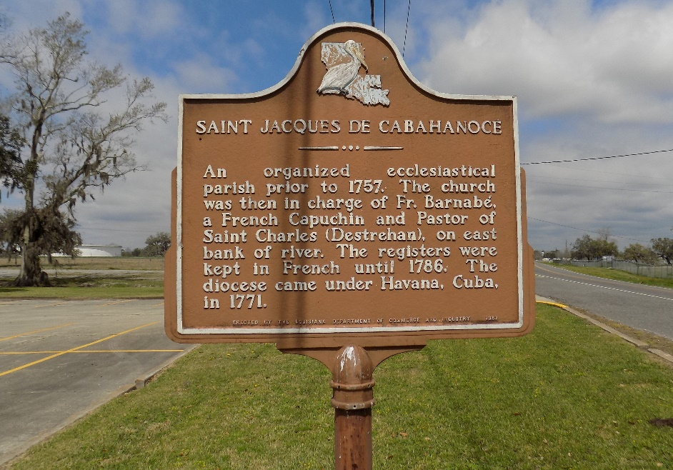

Byron D. Poirrier Jr., 55, a native and resident of St. James, LA, passed away on Saturday, September 7, 2019. Byron was a loving son, sibling, uncle and friend. Byron loved animals and enjoyed cooking.
He is survived by his father, Byron D. Poirrier Sr.; two siblings, Stacie Poirrier Gravois and husband, Brent and Danny Poirrier and wife, Jessica; one godchild, Kelsey Poirrier; two nieces, Demi Rene Gravois and Casie Lynn Poirrier; one great nephew, Zachary Poirrier and one great niece, Caroline Poirrier and a special lifelong friend, Linda Tassin.
Preceded in death by his mother, Gertrude Alberes Poirrier; grandparents, Gertrude and Freddie Alberes and Dolores and Rene Poirrier Jr.
Visitation will be on Thursday, September 12, 2019 from 8:30am until Mass of Christian Burial at 11am at St. James Catholic Church. Burial to follow in the church cemetery.
Ourso Funeral Home, Donaldsonville, Louisiana
Dignitymemorial.com

