Mavis Ann (Scioneaux) Prestley
June 28, 1952 – December 17, 2020

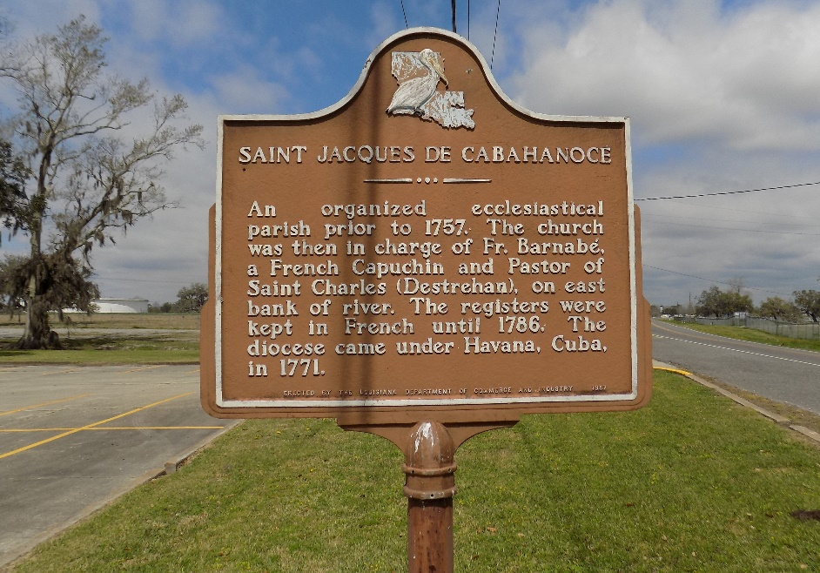

Mavis Ann Scioneaux Prestley, a native of St. James, LA, departed this life on Thursday, December 17, 2020 at the age of 68. She was born on June 28, 1952 in Donaldsonville, LA to the union of the late Joseph and Felonise Mayho Scioneaux, Jr. She was a graduate of St. James High School.
She worked at Agrico and two sewing factories before attending nursing school at Southeastern College. Due to physical disability, she was unable to fulfill her desire of caring for others. This did not put a damper on her spirit nor her desires for life. She was always happy and smiling, and willing to help others.
Mavis was a very loving, caring mother and grandmother. Her grandchildren were the apple of her eyes. Being able to talk to them through FaceTime calls gave her great joy. She enjoyed watching Lifetime and Hallmark movies. Mavis was also a die-hard Saints fan. She would often try to recruit her son-in-law to get on the Saints bandwagon.
Mavis leaves to cherish many loving memories her children, McKellia (Marvin) Dawson of Wichita, KS, Mendell Prestley of St. James, LA, McKita (Keldrich) Howard of Prairieville, LA and Malana (Brandon) Johnson of Baton Rouge, LA; grandchildren, Asia and Aubree Dawson, Reshawn, Reality and Reshad Moody, Mendell Prestley, Jr., Mason Ester and Maci Green; great-grandchild, Ace Moody; siblings, Kalvin Scioneaux, Joanne Jasmin, Debbie (Tyrone) Steib, Kenneth Scioneaux and Susan Scioneaux, ; sister-in-law, Judy Scioneaux; aunts, Gladys Joseph and Josephine Scioneaux; uncle, Lewis Scioneaux, and a host of nieces, nephews, other relatives and friends.
She is preceded in death by her parents Joseph and Felonise Mayo Scioneaux, brother Donald Scioneaux, and grandparents Joseph Scioneaux, Sr. and Abbie Jones, and Romalice Mayho and Octavia Wright.
Funeral Services will be held on Saturday, December 26, 2020 at Treasures of Life Funeral Services, 315 E. Airline Hwy, Gramercy, LA 70052, at 11:00am. There will be a public walk-through viewing beginning at 9am. Interment to follow at St. James Catholic Church Cemetery.
Treasures of Life Funeral Services, Gramercy, Louisiana

