Lillian (Keller) Preyan
April 4, 1921 – November 25, 2021

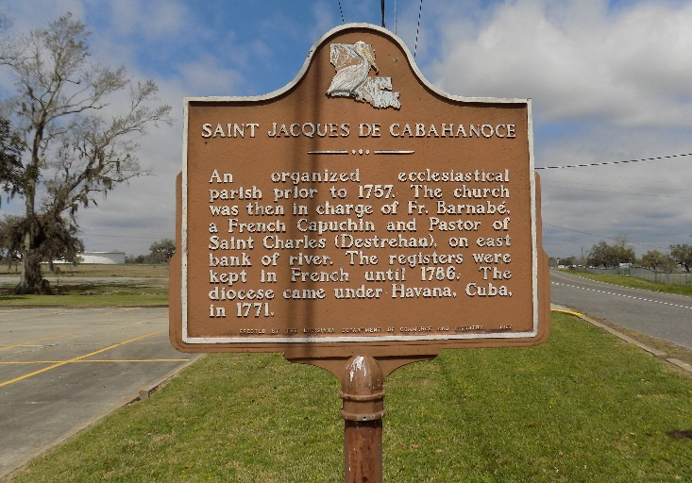

Sis. Lillian Preyan departed this earthly life on Thanksgiving Day, November 25, 2021, at her home surrounded by her family. Sis. Lillian was reared in St. James, LA. She was a member of St. Luke Baptiste Church where she served as a deaconess. Sis. Lillian Preyan's first great accomplishment was accepting Christ in her life at an early age. She was baptized in 1938 by Rev. Bush and had been a faithful member until her health and strength declined.
Sis. Lillian married the late Lesley Charles Preyan, and from this union six children were born. She leaves to cherish her precious memories five children, Betty Joseph of Houston, TX; Brenda Wilson of Gonzales, LA; Marva Dumas, Carliss (Dennis) Keller and Anthony (Louise) Preyan of Vacherie, LA; and Margaret (Henderson, Sr.) Taylor of Edgard, LA; Gerard Preyan of St. James, LA; nine nieces, Margaret Taylor, Lucille Dugar, Gracie Dumas, Vera Johnson, Wilhemina Palmer, Emma Young, Joyce Rome, Janet Stewart, and Carolyn Jackson; two nephews, Henry and Roland Jackson, one brother-in-law, Harold Preyan; two sisters-in-law Lillie Mae Preyan and Rita Brumfield; and two Godchildren, Lucille Dugar and Cassandra Comery.
MaLil was her name for the 14 wonderful grandchildren, 23 incredible great grandchildren and seven sweet great-great grandchildren, one blessed family who loved her so much.
She loved to cook and not only for the family but offering food to everyone who stopped by. Four days before her death, barely talking, she asked her granddaughter and husband if they wanted to eat. MaLil was still thinking about feeding the family. She was always excited to see her children and their children on Sundays and holidays ready to celebrate. MaLil was a very lovable, caring, quiet, and fun person to be around. MaLil enjoyed caring for her grandchildren so their parents could work, and she also loved to take care of her flowers and plants. MaLil was the BEST.
Sis. Lillian Preyan was a woman of God. She loved reading her Bible and encouraging everyone to pray and trust God, and when you pray, you pray for everyone. When she was asked about her longevity, she said prayed and trusted God, for He will take care of you. Her other great milestone was achieving her 100th birthday.
Sis. Lillian's favorite hymns are I've Been Redeemed, I Will Trust in the Lord, and Cooling Water. Her favorite Bible verses are Psalm 23, The Lord is my Shepard; Psalm 121: 1-2, I will lift up my eyes unto the hills, from whence cometh my help. My help cometh from the Lord; and Proverbs 3: 5-6, Trust in the Lord with all thine heart and lean not unto thine own understanding. In all thy way acknowledge him, and he shall direct thy paths.
Sis. Lillian was the youngest of nine siblings and she was the last surviving sibling. There are no more links in the chain!
She was preceded in death by her husband, Lesley Charles Preyan; daughter Regina Preyan Johnson; parents, Joseph and Lorenza Keller; sisters, Clara Jackson, Louise Collins, and Lydia Simon; brothers, Antoine Keller, Joseph Keller Jr., Richard Keller, Florian Keller, and Eddie Keller; step sisters, Emily Keller London, France Keller Alexis, Coretta Keller and Laura Keller Howard; niece Ethel Mitchell; sons-in-law, Wilton Joseph, Leo H. Wilson, Jr., and Robert Johnson; father-in-law Joseph Preyan; mother-in-law Ida Bazile Preyan; sisters-in-law, Annabell (Floyd) Oubre and Marcelite (Herbert) Clements; brothers-in-law, Joseph (Gladys) Preyan, Freddie (Victoria) Preyan and Howard (Vivian) Preyan. MaLil also leaves to cherish her loving memories to a host of other relatives, friends and adopted sons and daughters.
Visitation will take place at St. Luke Baptiste Church, 5030 Highway 18, St. James, LA 70086 on Saturday, December 4, 2021, from 10am until services begin at noon. Interment to follow at St. James Catholic Church Cemetery.
Treasures of Life Funeral Services, Gramercy, Louisiana

