Beverly Marie Priestley
About 1953 – August 14, 2021

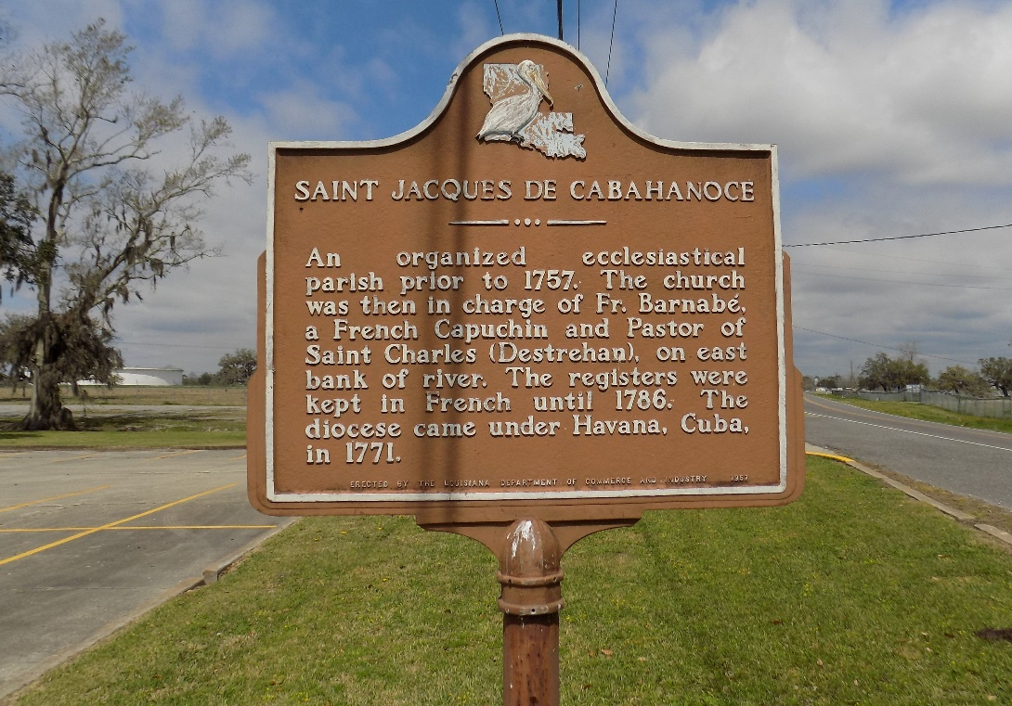

Beverly Marie Priestley departed this life on Saturday, August 14,2021 at St. James Hospital in Lutcher, LA. She was 68, a native and resident of Vacherie, LA.
Visitation on Friday, August 20,2021 at St. James Catholic Church from 9:00am to Mass of Christian Burial at 11:00am. Burial in the church cemetery.
Survived by 1 son, Rondell Priestley; 4 brothers, Jerome Priestley, Martin Champagne, Milton Priestley and Anthony Priestley; 2 sisters, Joyce Priestley and Brenda Brown; 1 grandchild; a host of aunts, nieces, nephews, other relatives and friends.
Preceded in death by her parents, Evelina and Lawrence Priestly; 1 brother, Stevenson Champagne; 1 sister, Roselee Priestley.

Williams & Southall Funeral Home, Napoleonville, Louisiana

