Jane (Hymel) Rivere
December 4, 1940 – May 17, 2023

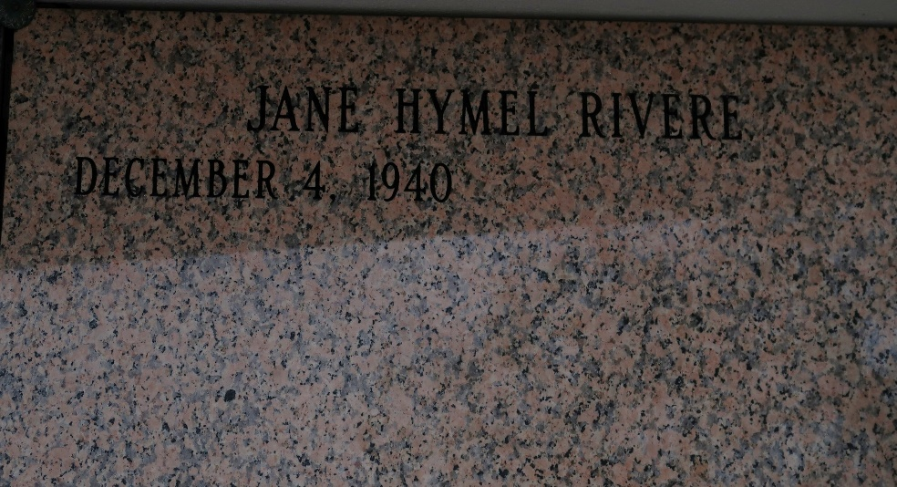

Jane “Lupie” Hymel Rivere, 82, a Native of St. James and resident Baton Rouge, Louisiana passed away on May 17, 2023. She is survived by her daughter, Denise Rivere, and son Autry Rivere, Jr. sisters, Carlyn (A.J.) Kleibert, Janet Ponson, Sisters in law; Teen Hymel, Grace Hymel, and Janice Hymel, brothers-in-law, Lionel “Jack” Bourgeois Jr. and Jimmy Becnel, grandchildren, Alex (Blake) Franklin, Kyle Franklin, Kelsey Franklin, Elise Rivere, Justin Rivere, and Hillary Rivere, greatgrandchildren; Jack Langley, John Kyle Kirk, Quinn Rivere, Luke Kirk, and Matilda Franklin.
She was preceded in death by her son, Barry James Rivere; Parents, Jules Hymel and Lucella Loup Hymel, brothers; Kelsey, Eddie, Warren, and Herman “T-boy” Hymel, sisters; Sylvia Bourgeois and Audrey Becnel, and brothers-n-law; Carroll Ponson.
Family and friends are invited to attend the Mass of Christian Burial at St. James Catholic Church,6613 LA-18, St James, LA on Wednesday, May 24th, 11:00am. Visitation will be from 9:00 until Funeral mass. Burial will follow in church cemetery.

Seale Funeral Service, Denham Springs, Louisiana

