Florida Marie (Mayo) Rodrigue
May 13, 1939 – January 30, 2024

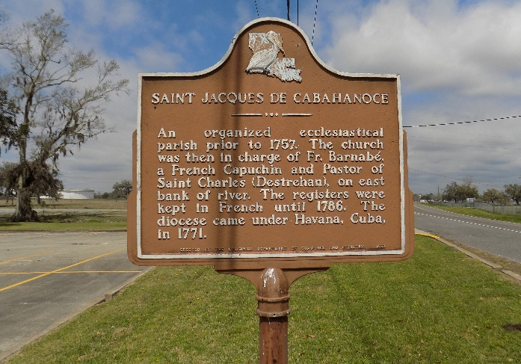

Our dearly beloved, Florida Marie Mayo Rodrigue departed this life for her heavenly home at the age of Eighty- four (84) years old. Florida died on Tuesday, January 30, 2024, at The Crossing at Clarity Hospice in Baton Rouge, LA. Florida was born on May 13, 1939, in St. James, LA, to the parents of the late Foster Mayo and the late Vivian Trepagnier Mayo. She was baptized and raised in the Catholic faith at an early age. She graduated from Magnolia High School in 1957. She married Oliver Rodrigue, Sr. in December 1959, and to this union five (5) children were born. In 1977, she welcomed a daughter, with then companion, Raymond Dupaty, Sr.
Florida leaves to cherish her loving memory, Five (5) children; Oliver Rodrigue, Jr, Preston Rodrigue, and Stephen Rodrigue, all of St. James. Belinda Poche (Elvin), of Modeste, LA and Patrice Dupaty Perkins (Rodney) of Baton Rouge, LA., Bonus Daughter, Trudy Dupaty Comeaux (Ronald). Five (5) Sisters; Judith Gaudia (Gerald), of Vacherie, LA, Claire Mayo, Betty Frazier, and Angella Landry (Willie), all of St. James. A Devoted Niece, Troye Ellis Poche, of Baton Rouge. Eight (8) Grandchildren; Donovan Deboue, and Vontriece Deboue Crayton (Bryan) of New Orleans, LA, Jacobi Poche, and Devoted Granddaughter Raelon "Jelly" Dupaty, and Zanaya Rodrigue, all of Baton Rouge, LA. Ronald Jr, Rondell and Ronnell Comeaux, all of Donaldsonville, LA. Eleven (11) Great Grandchildren; Lechelle, Dymond, Donovan Jr, Sampson, and Davionne Deboue, all of New Orleans, LA., Braylon, Champ, Isreal, Violet, and Ivy Crayton, all of New Orleans. One Great Great Grandchild; Kairo Pleasant. Ten (10) God Children. Devoted Friends, her Little Sister Marvis Brown, Cheryl Gray, Pauline Ambrose, and Catherine Dennis. Special Neighbors; Demetria Stewart and Ms. Rhonda.
Florida was preceded in death by her husband, Oliver Rodrigue, Sr., a Son Floyd Rodrigue. Parents, Foster Mayo and Vivian Trepagnier Mayo; Six Brothers; Norman, Harold, Clifford, Stephen Roy, Robert, and Lester Mayo. One Sister; Melba Mayo. Companion, Raymond Dupaty, Sr., Four Uncles; Whitney, Fred, Lloyd, and Amedee Mayo. Two Aunts; Margaret Louis, and Mable Phillips. A Host of Brothers-in-law, Sisters-in-law, Nieces, Nephews, Cousins, Relatives and Friends.

Demby & Son Funeral Home, Donaldsonville, Louisiana
Obituary published on Legacy.com on Feb. 1, 2024

