Mary Ann (Pierre) Rubin
March 27, 1943 – September 3, 2020

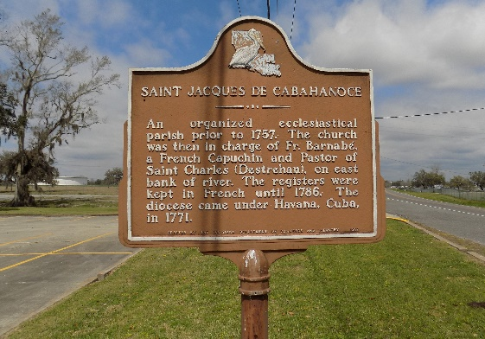

Mary Ann Pierre Rubin passed surrounded by her love ones on September 3, 2020 at the age of 77.
She loved family, life, beautiful things, cooking, crocheting and keeping everything clean and in order. She was a “glamour girl”, keeping up with her makeup and manicures. She also had a love for all music.
She was survived by her children, Edna Taylor (Willie), Marlene Burke (Darren), Jeannette Page (Cleophies), Juanita Harvey (Lionel, Jr.), Tonia Cooper (Darwin), Lloyd Rubin, and Shelton Rubin. She was formerly married to Edward Rubin. She is also survived by her brother, Joseph “Ulysses” Pierre; grandchildren, Irielle Webber, Javin Rodrigue, Ambria Sylvain, Whitney Sylvain, Gayland Hill, Jr, Genecia Hill Engham, Lashanta Rubin; and great-grandchildren, Jamaury Rubin, Amanii Rubin and Rhianna Johnson, Jacoby Davis, Rylee Engham, Russel Engham, Jr.
She was preceded in death by her parents, Theophile and Blanche Pierre; siblings of the Pierre family, Alex, Vivian, James, Wilhelmina, Bertha, Henry, Ernestine, Theresa, and Freddie.
A visitation in her honor will be at Rose Lynn Funeral Home in Lutcher, LA on Friday, September 11, 2020 from 8 AM to 10:00 AM. A Mass of Christian Burial will follow at 11:00 AM at St. James Catholic Church in St. James, LA. Burial will follow in the church cemetery.

Rose Lynn Funeral Home, Lutcher, Louisiana

