Pauline Shepard
January 13, 1905 – October 16, 2000

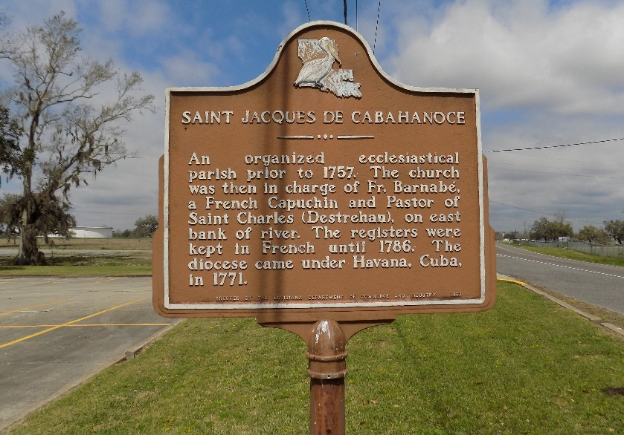

Pauline Shepard, a native of St. James, and resident of Luling, died Oct. 16, 2000. She was the mother of Welton Johnson. She was the daughter of the late Malvine Michel and Adam Shepard and sister of the late Stella Jacobs, Emma Marks, Leah Carter and Vilynn and Boon Shepard. She is also survived by four grandchildren.
Services were Oct. 19 at True Vine Baptist Church, Westwego, with interment at St. James Catholic Cemetery, St. James.

Unknown source
**

U.S., Social Security Applications and Claims Index, 1936-2007

Name Pauline Shepard
Gender Female
Race Black
Birth Date 13 Jan 1905
Birth Place New Orleans, Louisiana
Death Date 16 Oct 2000
Claim Date 20 Apr 1968
Father Adam Shepard
SSN xxx
Citizenship or Alien Status U.S. citizen.
Type of Claim Duplicate request; evidence of identity only submitted.
Notes 30 Nov 1998: Name listed as PAULINE SHEPARD

