Murphy June Steib
May 6, 1959 – November3, 2021

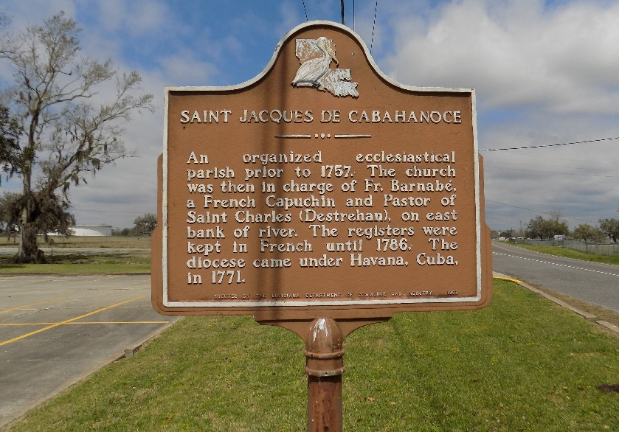

Our beloved Murphy, affectionately known as "Uncle Murph", "Big Murph", and "Bad Habit", quietly slipped away from us and departed his earthly home on Wednesday, November 3, 2021, at the age of 62.
Murphy was born on May 5, 1959 to the late Murphy Steib Sr. and Theresa Smith Steib. He was educated in the St. James Parish Public School System, and was employed as a truck driver for over 40 years.
Murphy was a hard worker. He took pride in his occupation as a truck driver. When he was not working, he enjoyed relaxing at home with a cold beer. On the weekends, he would joy-ride in his Camaro and socialize with family and friends.
He leaves to cherish his memories Marco and Jodie Collins, Jarrell and Cateria Young; sisters, Ruby Steib Joseph, Lisa (Joseph) Steib Washington, and Theresa (Earl) Steib Tassin, who was a dedicated and devoted caregiver to him, and a host of nieces, nephews, other relatives and friends.
Murphy was preceded in death by Murphy Steib Sr. and Theresa Smith Steib; sisters, Gladys Becnel, Maxine Clarence, Marilyn Pierre, Gail Rodney, and Rose Mary Steib, and nephew Ellis Becnel Jr.
Services for Murphy Steib Jr. will be held on Saturday, November 13, 2021, at Treasures of Life Funeral Services' temporary location 22131 Hwy 20, Vacherie, LA 70090 (The Diamond Center) at 11am. Visitation will be held from 10am-11am. Interment to follow at St. James catholic Church Cemetery in Saint James, LA.

Treasures of Life Funeral Services, Gramercy, Louisiana

