Eugene Sutherland Sr.
September 13, 1954 – September 22, 2024

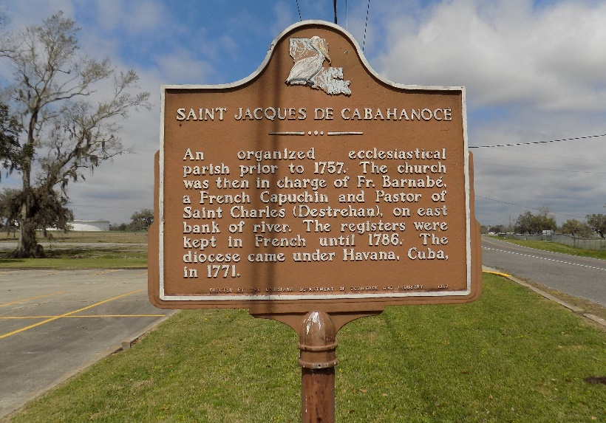

Eugene "Poppee" Sutherland, Sr. was born September 13, 1954, in New Orleans, Louisiana to Marline and Clinton Sutherland, Sr. He was the sixth of ten children born to their union. He was raised and confirmed at St. James Catholic Church in St. James, Louisiana where he was able to develop a lasting relationship with God and his Lord and Savior Jesus Christ. He was a student at Magnolia High School where he received his diploma in 1972. He entered into the workforce immediately and found himself to be a swift learner of many trades. He became a father at 19, which gave him the motivation to "hustle" for whatever was needed.
Poppee started as a truck driver for local industry and Owner/Operator. He enjoyed many adventures driving across the country, and was even able to take a few family members with him along the way! He earned the handles "Gear Jammer" and "Truck Doctor" which are both pretty self explanatory. When he would return home between assignments he couldn't wait to recount some of the tall tales he had heard, many, many times and told them for years.... even after leaving the cross country trucking industry to be closer to his family. He came home and began driving during the harvest season, and welding during the off season. However, he never had a break from his mechanic work. Everyone in the community knew that if they needed a diagnosis on something wrong with their vehicle, Poppee was only a call away. He enjoyed helping people, conversing with just about anyone and took pride knowing that he had made a difference for them whether it was big or small. He continued as a welder for several Louisiana based companies and before his health scare in 2012, he had his last ride as a trucker during the harvest season. With God's help, the love and support of his family, and the staff at Our Lady Of the Lake Hospital in Baton Rouge, he was able to make a near full recovery from the subarachnoid hemorrhage that caused his stroke.
Although he was unable to continue driving trucks or welding he found a new purpose in spoiling and helping to raise his grandchildren and cutting grass around the community. He also became a member of the Rising Sun Benevolent Society. Eventually he found his way back to driving, through his volunteering with the church to deliver groceries and commodities to residents in need. He would even joke sometimes that when he FINALLY would win the lottery, some of his money would go toward rounding up the elderly in the community and taking them to a casino at his expense. "They need to have fun too, you know!"
Over the course of his life, Poppee kept a positive attitude and every single night he took care to kneel and give reverence to God. He knew that despite the obstacles he faced and trials and tribulations he overcame his reward would be in heaven. Although he passed suddenly, he longed to see his loved ones again and there is peace and comfort in knowing that he was received by waiting arms.
He will be sadly missed by his loving and devoted wife of 44 years Marilyn F. Sutherland, his son Eugene (Danee) Sutherland, daughters Darilyn (Ricky) Green and Ciara (Davin) Dennis; 6 grandchildren, Reanna Sutherland, Nyrie, Ricky III, and Lauryn Green, Marlie and Marsai Dennis; sisters Zedel (Harry) Oubre and Matilda Sutherland, brothers Gerry Sutherland, Herman (Charlene) Sutherland and Thaddeus (Laura) Sutherland, brothers-in law Joseph Fefie and Cleveland Fefie, Sr. Sisters in law- Felicia Fefie, Theresa Zenon, Odette Fefie, Doris Truehill, Betty Jones, Antoinette Fefie, aunt Ora Lee Ferchaud, godchildren Clinton Sutherland III, Dr. Delwin Mitchell and Verdell Ferchaud, a host of nieces, nephews, cousins, friends from Blue and Son's Grocery, and former co-workers. A Mass of Christian
Burial will be held on Saturday, October 5, 2024 at St. James Catholic Church, 6613 LA-18, St. James, LA 70086 with visitation beginning for 8:30 AM and mass to follow for 10:30 AM. Internment St. James Catholic Church Cemetery, 6613 LA-18, St. James, LA 70086. Final care and professional services are entrusted to Treasures of Life Funeral Services, 315 E. Airline Hwy., Gramercy, LA 70052.

Treasures of Life Funeral services, Gramercy, Louisiana
October 3, 2024

