Marline (Ferchaud) Sutherland
July 10, 1930 – May 13, 2011

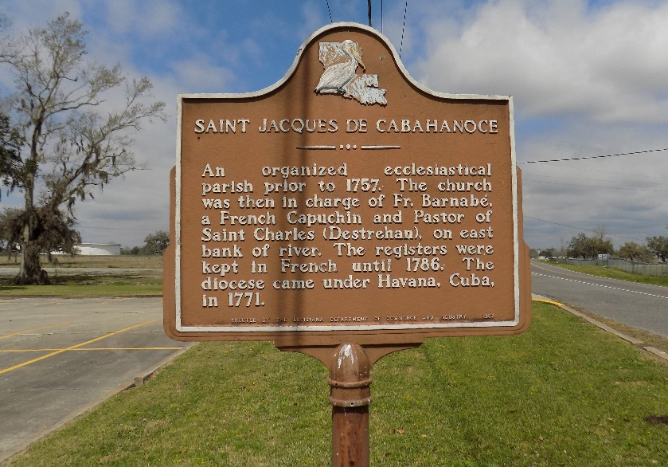

Marline Ferchaud Sutherland, a retired school bus driver for St. James Parish, passed away at 9:15 a.m. on May 13, 2011, at the age of 80.
Mass of Christian Burial will be held at St. James Catholic Church, 6613 Hwy. 18, St. James, on Saturday, May 21, 2011 at 11:00 a.m. Visitation from 9:00 a.m. until time of service. Father Christopher Decker officiating. Burial at church cemetery.
Marline is survived by her children, Clinton Jr. "Butch", Joyce Geason (Charles), Zedel Oubre (Harry), Allen (Cindy), Thaddeus Sr. (Laura) all of Vacherie; Tyrone Sr., Gerry, and Eugene Sr. (Marilyn) of St. James; Herman (Charlene) of Donaldsonville; and Mathilda Borne of Baton Rouge; also, 32 grandchildren, 49 great- grandchildren and 1 great great-grandchild; her devoted brother-in-law Charles Sutherland, and sister-in- law Ora Lee Ferchaud, other in-laws, nieces, nephews.
Preceded in death by her husband, Clinton Sutherland; parents, Eugene and Mathilda Ferchaud; grandson, 10 siblings, several in-laws, nieces, and nephews.
Arrangements by The Baloney Funeral Home LLC, 399 Earl Baloney Street, Garyville, LA.
Times Picayune, New Orleans, Louisiana
May 20, 2011
**

U.S., Social Security Death Index, 1935-2014

Name Marline F. Sutherland
Social Security Number xxx
Birth Date 10 Jul 1930
Issue year 1965
Issue State Louisiana
Last Residence 70086, Saint James, Saint James, Louisiana
Death Date 13 May 2011

