Tyrone Anthony Sutherland Sr.
January 4, 1949 – June 5, 2022

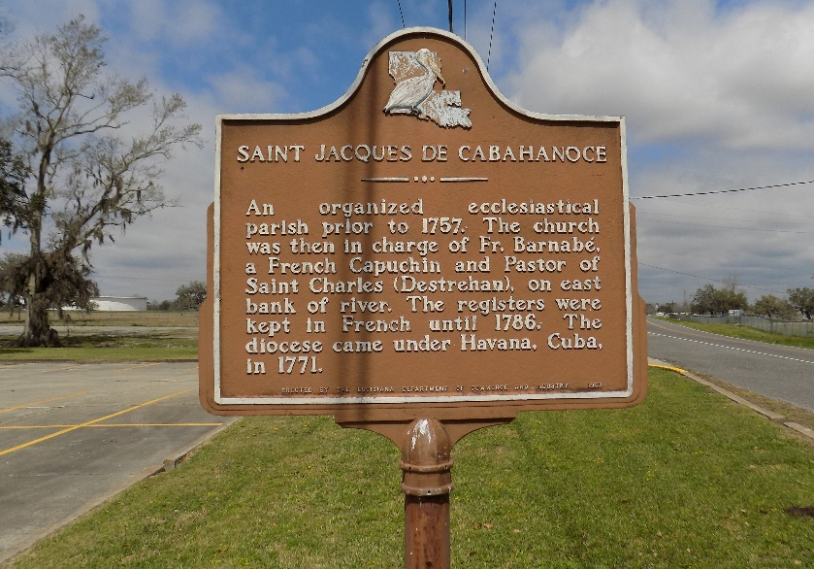

Tyrone Anthony Sutherland, Sr. was born on January 4, 1949, in St. James, LA to the late Marline Ferchaud Sutherland and the late Clinton Sutherland, Sr. On Sunday, June 5, 2022, he was called by God to his eternal home at the age of 73.
Tyrone, a dependable and selfless provider, leaves to cherish his legacy and memory: children Shawanda (Gerald) Richardson, Angelic (Vyron) Keller, Tyrone (Abril) Jr. and Randy (Shanna) Sutherland; grandchildren Trey, Tai, Jolina, Angel, Colin, Baleigh and Kelsi Sutherland, Austin Alexis, Tyler Adams, Victoria Keller, Dontrell Sr. and DeQuincia James, and Gabrielle Richardson; 3 great-grandchildren, sisters Zedel (Harry) Oubre and Mathilda Borne, brothers Clinton Sr., Herman (Charlene), Eugene (Marilyn), Gary, and Thaddeus, Sr. (Laura), sister-n-law Cindy, and a host of nieces and nephews, other relatives and dear friends.
He was preceded in death by his parents Marline Ferchaud Sutherland and Clinton Sutherland, Sr., sister Joyce Geason, brother Allen Sutherland, and sister-in-law Elaine Sutherland.
Visitation will be held at the Baloney Funeral Home, 1905 W. Airline Highway in LaPlace, LA on Sunday, June 12 from 5 pm - 7 pm, and at the St. James Catholic Church, 6613 LA 18 in St. James, LA on Tuesday, June 14 from 11:00 am until the religious service begins at 1:00 pm. Interment immediately following at the St. James Catholic Church Cemetery.
Times Picayune, New Orleans, Louisiana
June 10-14, 2022

