Shirley (Brown) Trepagnier
1928 – November 21, 2010

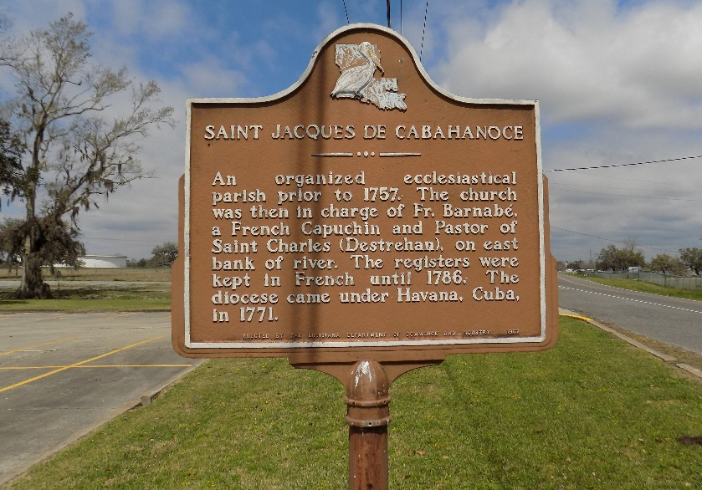

Shirley Trepagnier transitioned to be with the Lord on Sunday, November 21, 2010. She was 82. Beloved wife of the late Fred J. Trepagnier, Sr. Mother of Oliver, Val and the late Fred (Bettie) Trepagnier, Jr. and Wilfred (Speedy) Henley, Jr. Daughter of the late Virginia Barnes and Oliver Brown. Step- daughter of Birdie Brown. Sister of Alvin Brown and the late Eunice Richard. She is also survived by 2 grandchildren, 4 great grandchildren and one great great grandchild.
Her death was preceded by Renise Trepagnier, her 1st grandchild. She is survived by a host of relatives and friends.
All are invited to attend the services on Friday, November 26, 10:00am at Rhodes Chapel, 3933 Washington Ave., NOLA. Visitation from 8:00-10:00am. Rev. Donald Burris, officiant. Interment will follow in St. James Cemetery, LA 18, St. James, LA. Arrangements entrusted to Rhodes Funeral Home.
Times Picayune, New Orleans, Louisiana
November 25, 2010

