Edna Marie (Meadows) Weber
1933 – July 10, 2024

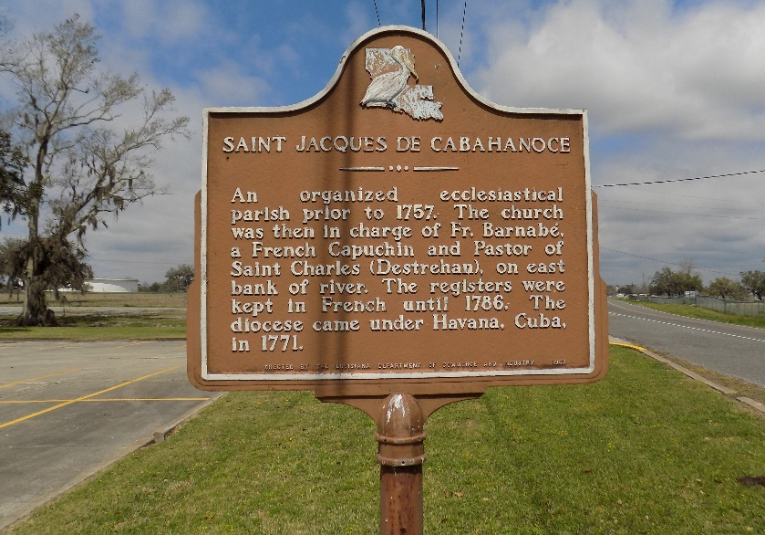

Edna Marie Weber departed this life on Wednesday, July 10, 2024, at Advent Health Hospital in Wesley Chapel, FL. She was 91, a native of Sabine, West Virginia and a resident of Vacherie, LA until 2022 when she moved to Wesley Chapel, FL.
Visitation on Thursday, July 18, 2024, at St James Catholic Church, 6613 LA-18 St. James, LA 70086, from 9:00am to Mass of Christian Burial at 11:00am. Entombment in the church mausoleum.
Survived by 2 Sons, Anthony Weber (Lisa) of Wesley Chapel, FL, and Edmund Weber of Lakeland, FL; Bonus Children, Damian Pedescleaux and Candace Weber; 1 Sister, Ruby Allen of Detroit, MI; ;4 grandchildren; 5 Great Grandchildren; a host of nieces, nephews, other relatives and friends.
Preceded in death by her husband, Joseph J. Weber; her grandmother who raised her, Elizabeth Jones; her parents: Bertha and Richard Meadows; 1 daughter Jemma Weber; 3 sisters Elizabeth Price, Grace Mason, and Thelma Toler; 2 brothers George West and Richard Meadows; 3 brothers-in-law, Thornton Price, John Mason, and Wiley Toler; 1 sister-in-law, Lilian Meadows.

Williams & Southall Funeral Home, Donaldsonville, Louisiana

