Jemma Iris Mercedes Weber
January 9, 1963 – February 28, 2016

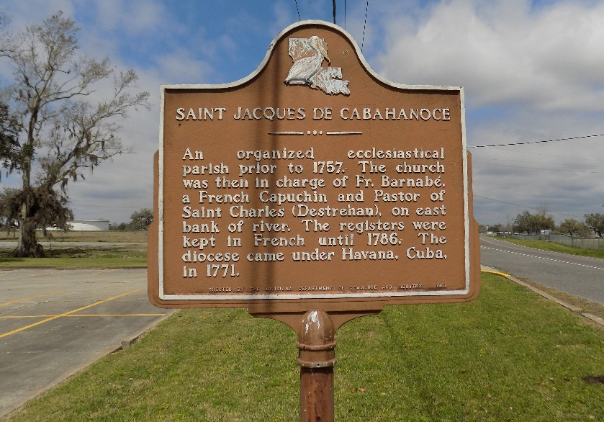

On Sunday, February 28, 2016, Jemma Iris Mercedes Weber transitioned from her earthly home to her heavenly home in glory.
Jemma was the loving mother of Devin Joseph Pedescleaux whom she shared with her devoted friend Damian Pedescleaux. Jemma was the second child born to Joseph "Jonoid" and Edna Meadows Weber on January 9, 1963.
She was a graduate of St. James High School class of 1981. She continued her education at Nicholls State University where she earned her degree in University Studies. She was employed at St. Elizabeth Hospital in Dietary Services for over 25 years. She was faithful and dedicated member of St. James Catholic Church serving in the gospel choir since its inception.
Jemma was a member of Division, Knights and Ladies KPC Council Court #135. She was a well-liked and conscientious employee of St. Elizabeth Hospital. She was a devoted friend but most of all she was a dedicated and loving mother. She was avid reader who enjoyed her quiet time with a good book. She had a wonderful sense of humor and enjoyed a good laugh. She was also a faithful Saints fan who didn't miss a game on TV.
She also leaves to cherish her fond memories, two brothers, Anthony "Tony" Weber and Edmund Weber; one sister-in-law, Lisa Weber; one devoted friend Damian Pedescleaux and a host of relatives and friends.
Relatives and friends of the family, also Priests and parishioners of St. James Catholic Church and neighboring churches are invited to attend a mass of Christian burial on Thursday, March 3, 2016, at 11:00a.m. at St. James Catholic Church, 6613 LA. 18, St. James, LA. Father Christopher Decker celebrant. Interment in the Church Cemetery. Visitation with family at the church begins at 9:00 a.m.

Treasures of Life Funeral Services, Gramercy, Louisiana

