Myrtle (Mayho) Weber
1920 – January 20, 2018

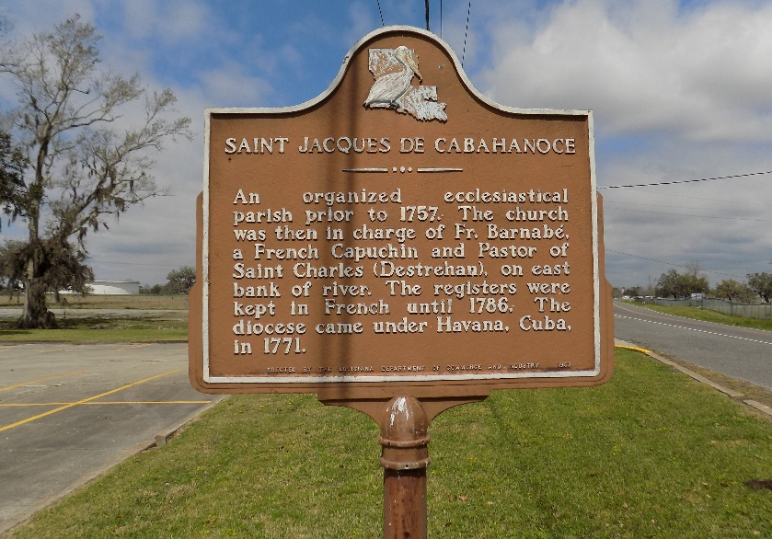

Myrtle "Mother Dear" Weber departed this life on Saturday January 20, 2018 at her residence in Vacherie, LA. She was 97, a native of St. James, LA.
Visitation on Saturday, January 27, 2018 at St. James Catholic Church, St. James, LA 8:00am to Mass of Christian Burial at 11:00am. Recitation of the Holy Rosary at 9:30am. Officiated by Father Brad Doyle. Burial in the Church Cemetery.
Survived by 2 sons, Allen (Beryl) and Wayne Weber; 2 daughters, Cherly Landry (Louis) and Conchita Weber-Joseph (Donriel); 1 daughter in law, Harriet Weber; 1 sister in law; Geraldine Mayo; 13 grandchildren; 21 great-grandchildren; 10 great-great grandchildren; also a host of other relatives and friends.
Preceded in death by her husband; Adam Russell; parents; Octavia and Romalice Mayho; 1 daughter; Maxine Weber; 1 son, Raleigh Weber, Sr.; 1 grandson; 3 great-grandchildren; 2 sisters, Felonise Scioneaux and Mary Williams; 2 brothers, Matthew and Marshall Mayho.

Williams & Southall Funeral Home, Napoleonville, Louisiana

