Edna Mae Williams
December 24, 1933 – December 19, 2020

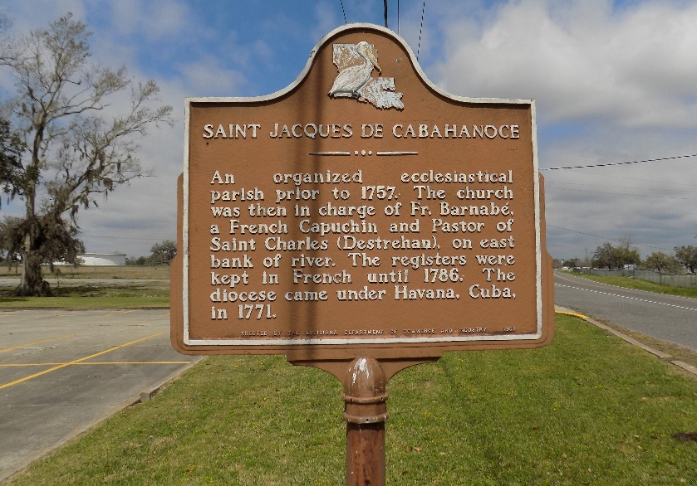

Mrs. Edna Mae Williams, affectionately known as "Tutt Tutt", was born on Christmas Eve to the late Felix Joseph and Nolia Johnson in 1933. The Angels of Mercy summoned her home December 19, 2020, at Thibodaux Regional Hospital. She was 86 years old. She was married to the late Mr. James Williams, Sr. for 59 years. Of this union seven children were born.
Forever cherishing her memory are her children, James Jr. (Annie) of Macon, GA, Kevin (Gwen) of Niceville, FL, Judith (Robert) Geason, Elaine (Anthony) Julien, Erica (Kirk) Carey all of St. James, LA.
She also leaves to cherish her memory her daughters-in-law Lois, Dale and Corrine Williams, Ruby Harkless, Brenda Mays Malone, and Carolyn Johnson, one brother-in-law, Junios (Carolyn) Williams, sister-in-law, Lee Ester Johnson, three sisters, Laura Sims, Doreen (Lawrence) Ketchens, Mable Landry of Atlanta, GA, two brothers, Giles Joseph and Willie (Jackie) Joseph. She was a loving grandmother of 15 grandchildren, 27 great-grandchildren and three great-great-grandchildren. She was the godmother to Patricia Nelson and will be missed by a host of nieces, nephews, and friends.
She was preceded in death by her husband, James Williams, Sr., two sons, Melvin and Ronald Williams, parents, Felix Joseph and Nolia Johnson, maternal grandmother, Jeannie LaCroix, brothers, Charles Augusta and Felix Joseph, sister, Carrie Wilson, uncles, John Winchester Sr., Richard Nelson, Claude Washington and brother-in-law Julian Sims.
Viewing shall be on Wednesday, December 30, 2020, from4 p.m. to 6 p.m. at the Baloney Funeral Home, 1905 West Airline Highway, LaPlace, 70069. Funeral service shall be on Thursday, December 31, 2020, at 1030 a.m. at St James Catholic Church, 6613 LA-18, St. James, LA 70086. Interment immediately following at St. James Cemetery.
The Times-Picayune, New Orleans, Louisiana
Dec. 29 to Dec. 30, 2020

