Oliver Winchester Sr.
1932 – October 16, 2014

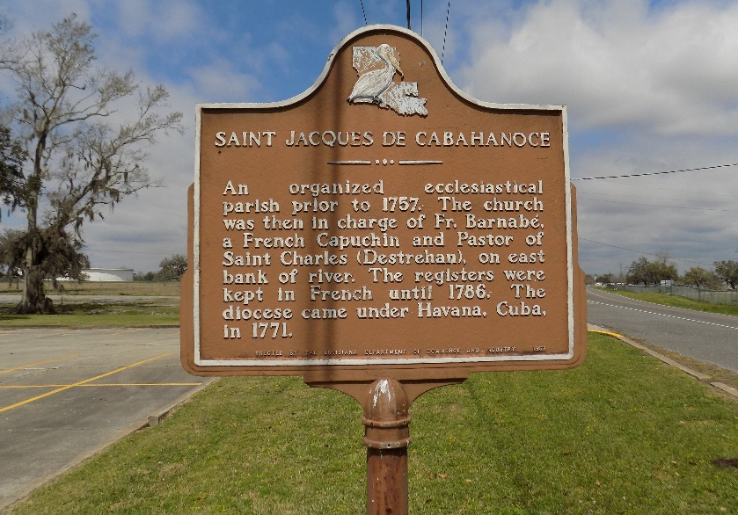

Oliver "Blue" Winchester, Sr., Age 82, died October 16, 2014, at 10:50 p.m., at Crossing Clarity Hospice in Baton Rouge, LA. He was a lifelong business owner of Blue's & Son's Grocery in St. James Parish.
He was a loving father to six children, Diane Winchester-St. James, Oliver Winchester, Jr., (Sonja), Paula Winchester Raheem (Ishmail), Margaret White (Alex), Isabella Johnson (Ronnie), Kenneth Winchester, Sr. (Wanda) and grandfather to 12 children and 8 great-grandchildren.
Visitation will be held on Thursday, October 23, 2014, at 8:30 a.m. until Mass of Christian Burial at 11:00 a.m. at St. James Catholic Church, 6613 Hwy 18 St. James, LA. Interment at St. James Cemetery.
The New Orleans Advocate, Louisiana
Oct. 21 to Oct. 23, 2014

