Dianne Mary Winfield
October 14, 1943 - December 18, 2024

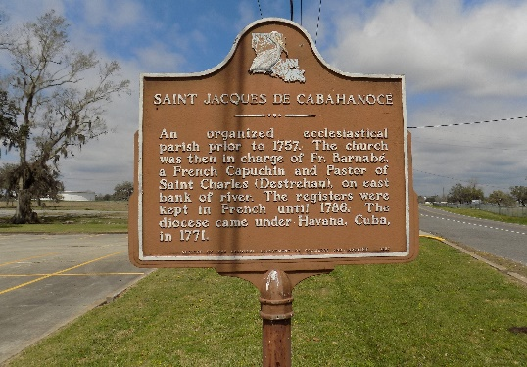

December 18, 2024, Dianne Mary Winfield of Killeen, Texas calmly and peacefully passed away. Dianne was the oldest of 5 children, and all grew up in St. James, Louisiana. Dianne graduated from Magnolia Sr. High School, Vacherie, Louisiana. She migrated to New Orleans, LA, then to Houston, Texas.
When Dianne and her son Stacy, settled in Alexandria, Virginia, she found a wonderful position as governess to a family with 2 wonderful children. She remained in Alexandria, Virginia, and bonded her loving relationship with her grandson Brandon, and his mother. She remained very close to her working family after retiring. Dianne moved to Killeen, Texas, to be close to her son, his wife and their two daughters. Settling into the Killeen area, she was aided by the wonderful friends she met and prayed with in her prayer groups and church services.
She is survived by her son, Stacy (Allison); One grandson, Brandon (Tiphenie); Two granddaughters, Kara and Jasmine; One great grandson, Na'im Salish X David Jr. Two brothers: Paul Winfield, Sr. (Marchillia), Wilbert Hogan. Two sisters: Cecilia Winfield-Harrell, Margaret Dorsey. A host of nieces, nephews, cousins, and friends.
Proceeded in death by her parents Thomas and Velma Winfield, Jr.; one sister, Judith Ambrose; one brother, Thomas Winfield.
"Rejoice with those who rejoice; Mourn with those who mourn. - Romans 12:15. A celebration of life, love, and legacy will be held on Saturday, January 11, 2025 at St. James Catholic Church, 6613 LA-18, St. James, LA 70086. Visitation begins for 8am followed by service for 10:30am. Interment St. James Catholic Church Cemetery, 6564 LA-18, St. James, LA 70086.

Treasures of Life Funeral Services, Gramercy, Louisiana
January 13, 2025

