Annabel (Newitt) Wood
December 25, 1938 – July 3, 2022

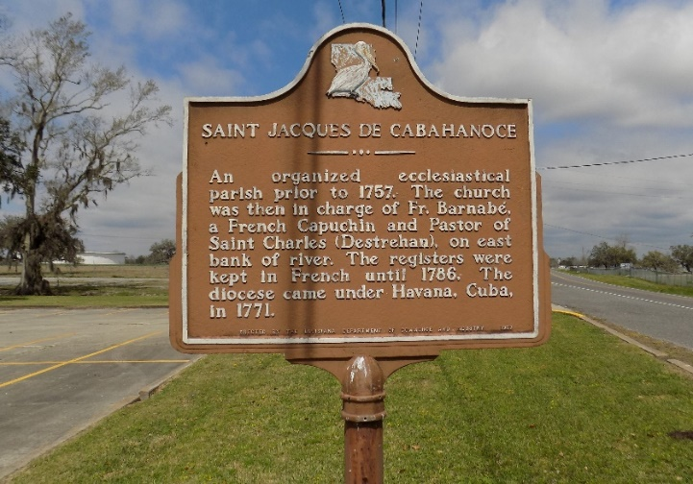

Annabel Newitt Wood, age 83, lifelong resident of St. James and 4 year resident of Gonzales, Louisiana passed away on Sunday, July 3, 2022. Annabel was born December 25, 1938.
Annabel is survived by her husband of 64 years, James J. Wood, Jr; step-father, Herman F. Torres, Sr.; daughters, Donna Hincks, Janel Bourgeois (Eddie) and Mary Morgan (Milton); son, James Wood, III; sisters, Shirley Usey and Karen Hernandez (Tracy); brother, Herman F. Torres, Jr. (Michelle); grandchildren, Leigh Morris, Anne B. Allen, Emily B. Cowley, Leslie Bourgeois, Hogan Bourgeois, Lindsey Wood, Peyton Wood, Ellie Wood, Brandon Cofield, Terence Cofield and Holden Ourso; 8 great grandchildren.
Annabel is preceded in death by her father, John Leslie Newitt; mother, Anabel S. Torres; father and mother -in-law, James Wood, Sr. and Anne R. Wood; grandparents, Michele and Anabel Schexnayder; son-in-law, Joel Hincks; sister-in-law, Anne W. Perque; brother-in-law, Cedric Usey; nephew, Edgar Schexnayder.
Annabel was a longtime choir member at St. James Catholic Church, Our Lady of Peace Catholic Church and St. Joseph the Evangelist. She enjoyed working in her garden, sewing, and sharing arts and crafts projects for those she loved.
Visitation will be held on Friday, July 8, 2022 at St. James Catholic Church, 8:30am - 11am. Mass of Christian Burial will be held at 11am on Friday, July 8, 2022, at St. James Catholic Church. Burial will be in the church cemetery.
In lieu of flowers donations can be made to St. Jude Children's Research Hospital or to a charity of your choice.

Ourso Funeral Home, Donaldsonville, Louisiana
Dignitymemorial.com

