Henry J. Bourgeois Jr.
December 10, 1925 – January 21, 2002

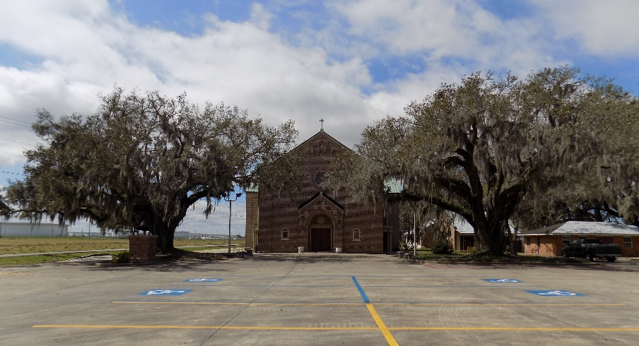

Henry J. Bourgeois, Jr. died Monday, January 21, 2002 at his residence. Beloved husband of Carol W. Bourgeois. Father and father-in-law of Peggy Bourgeois, Stephenie B. and Brett Hoggart of Gramercy, LA, Carolyn B. and Paul Bossier of Lutcher, LA, David Bourgeois of New Orleans, LA. Grandfather of Patrick and Claire Bossier, Melvin and Henry Lee Istre of Prairieville, LA. Preceded in death by three children: Juanita Istre, Sharon and Michael Bourgeois; his parents: Henry J. Bourgeois, Sr. and Mary B. Bourgeois and brothers: Richard and Kenneth Bourgeois. Age 76 years. A native of Morgan City, LA and a resident of Gramercy, LA. A U.S. Navy Veteran whom served in World War II and the Koren Conflict. A member of Veterans of Foreign Wars. Relatives and friends of the family are invited to attend the funeral services. A Mass of Christian Burial will be celebrated by the Rev. Ed Fuss at St. Joseph Catholic Church, Paulina, LA on Wednesday, January 23, 2002 at 10:30 a.m. Friends may call at H.C. ALEXANDER FUNERAL HOME OF LUTCHER, 2208 JEFFERSON HIGHWAY on Tuesday evening from 6:00 until 9:00 and on Wednesday morning from 8:00 until 10:15. Interment follow in St. Joseph Cemetery. In lieu of flowers, the family request donations to St. James Cancer Services.
Times-Picayune, New Orleans, Louisiana
Tuesday, January 22, 2002
**

BOURGEOIS PAULINA – Henry J. Bourgeois Jr., 76, a native of Morgan City and resident of Gramercy, died Jan. 21. He was the husband of Carol W. Bourgeois and father of Stephanie Hoggatt, Carolyn Bossier, Peggy and David Bourgeois and the late Juanita Istre, Sharon and Micheal Bourgeois. He was the son of the late Henry Sr. and Mary B. Bourgeois and brother of the late Richard and Kenneth Bourgeois. He is also survived by four grandchildren. He was a U.S. Navy veteran of World War II and the Korean Conflict. Services are today at 10:30 a.m. at St. Joseph Catholic Church, Paulina, with interment at the church cemetery. Visitation starts at 8 a.m.

L’Observateur, LaPlace, Louisiana
Thursday, January 24, 2002

